**Tukwila-Allentown Air Quality – Final Update**

**Goal:** To measure air quality levels in the Tukwila-Allentown neighborhood.

**What were some of the community’s questions?**

* Are air pollution levels roughly the same across Allentown?
* Is there more air pollution near the railyard and 124th St than the rest of the neighborhood?
* How do air pollution levels in Allentown compare to other Puget Sound urban areas?

**What we’ve learned so far:**

* Fine particle levels were higher near the intersection of 42nd Ave & 124th St and the air monitoring station in Duwamish Park compared to other sites in Allentown.
* Ultrafine particle levels vary across Allentown and seem to be higher near the entrance to the railyard.
* Fine particle and black carbon levels in Allentown are similar to other places in the Puget Sound region.

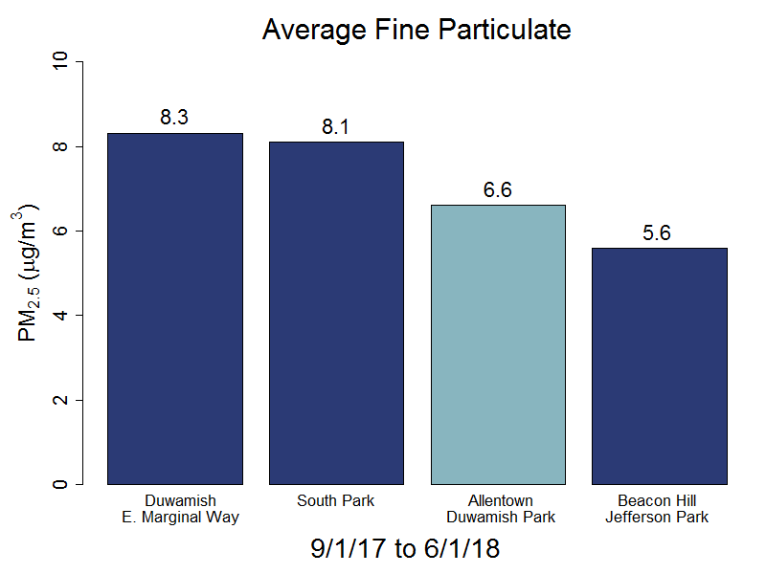**How do air pollution levels in Allentown compare to other Puget Sound urban areas?**

The bar chart to the left shows the average level of fine particles (also known as PM 2.5) from September to June for Allentown, Beacon Hill, E. Marginal Way, and South Park. Fine particles are the type of air pollution we measure the most because of its health impacts (see back page for more information on this).

Based on these data, **fine particle levels in Allentown were similar to and slightly less than other sites in the Duwamish Valley.** Levels at all sites are below national health-based air quality standards.

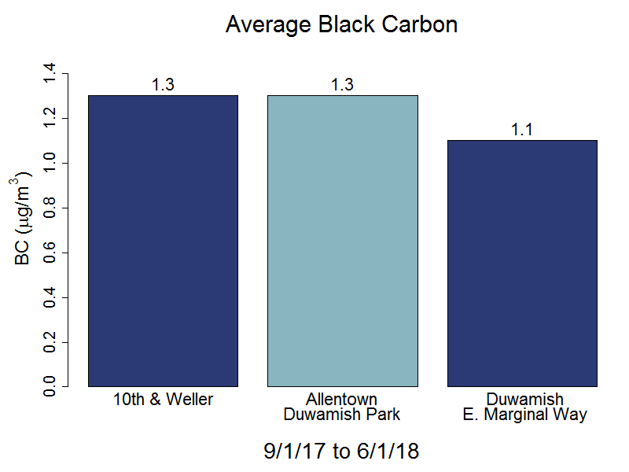

The bar chart on the right shows the average level of a type of particle pollution called black carbon that is associated with diesel exhaust and wood smoke. Black carbon levels in Allentown were similar to black carbon levels at 10th and Weller, a site located near the I-5 freeway and E. Marginal Way.

**How did we measure air pollution levels?**

We measured fine particle pollution and black carbon – types of air pollution that are closely related to transportation (cars, trucks, etc.) and wood smoke. To see how fine particle and black carbon levels differ throughout Allentown, we used the air monitoring station in Duwamish Park (located near 44th Ave).

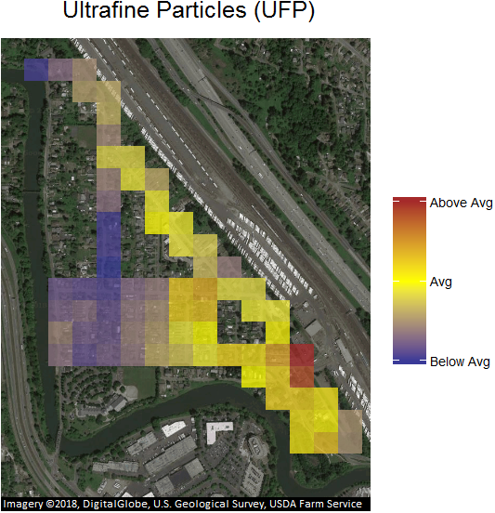We also attached a portable air monitor to a bicycle and rode across Allentown to look at the levels of ultrafine particles across the neighborhood. The instrument on the bicycle isn’t perfect, but it is a helpful way to gather information and is easy to use.

**Where are ultrafine particle levels higher?**

The map to the right shows the distribution of ultrafine particles across Allentown. This map is based on 17 bike rides on several different days in different seasons. The map takes the data from each bike trip’s “snapshot in time.” The blue squares indicate areas that have ultrafine particle levels below the average in Allentown, the yellow squares indicate average ultrafine particle levels, and the brown squares indicate higher ultrafine particle levels.

Based on these data, ultrafine particle levels are highest near the entrance to the railyard.

**What are the health risks from particles and black carbon?**

Fine particles (less than 2.5 microns in diameter, also known as “PM 2.5”) can reach the deepest part of our lungs. Decades of research have shown that fine particles can worsen breathing and heart problems, such as asthma, cause heart attacks, strokes, and lead to premature death. These health impacts are greater for sensitive populations like children, the elderly, and people with pre-existing health conditions. Black carbon is associated with combustion and is a particularly toxic portion of fine particles.



Ultrafine particles are even smaller than fine particles (less than 0.1 microns in diameter). While not much is yet known about the health risks of ultrafine particles, some studies suggest similar heart and breathing impacts.