Tukwila-Allentown Air Quality – 1st Update
Goal: To measure air quality levels in the Tukwila-Allentown neighborhood due to community concerns.
What were some of the community’s questions?
- Is there more air pollution near the railyard and 124th St than the rest of the neighborhood?
- Are air pollution levels roughly the same across Allentown, or are there gradients?
- How do air pollution levels in Allentown compare to other Puget Sound urban areas?
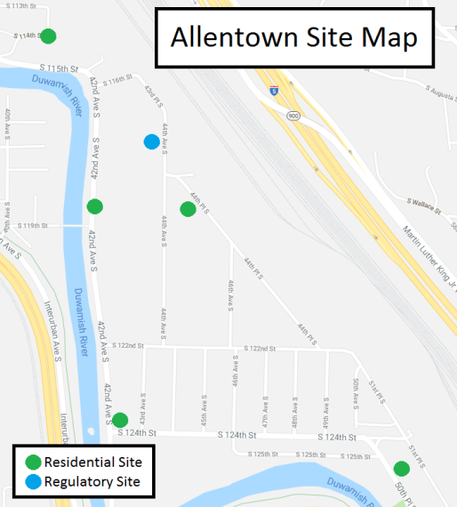
What we’ve learned so far:
- Fine particle levels were higher at the 42nd Ave & 124th St site and the air monitoring station in Duwamish Park compared to other stationary sites in Allentown.
- Ultrafine particle levels vary across Allentown and seem to be elevated near the entrance to the railyard.
- Fine particle levels in Allentown are similar to other places in the Puget Sound region. The monitor at 42nd Ave and 124th St had a higher average fine particle concentration than the regulatory site on 44th Ave.

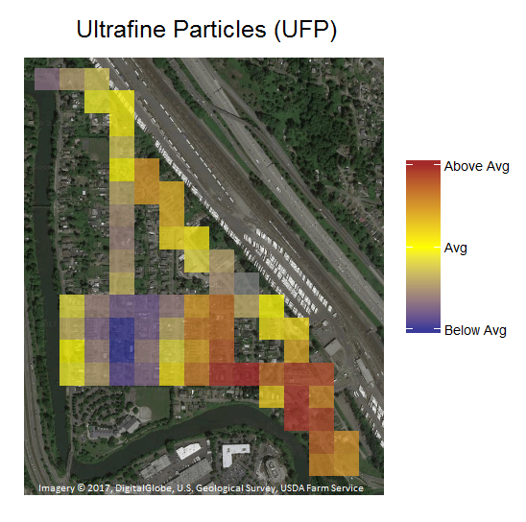
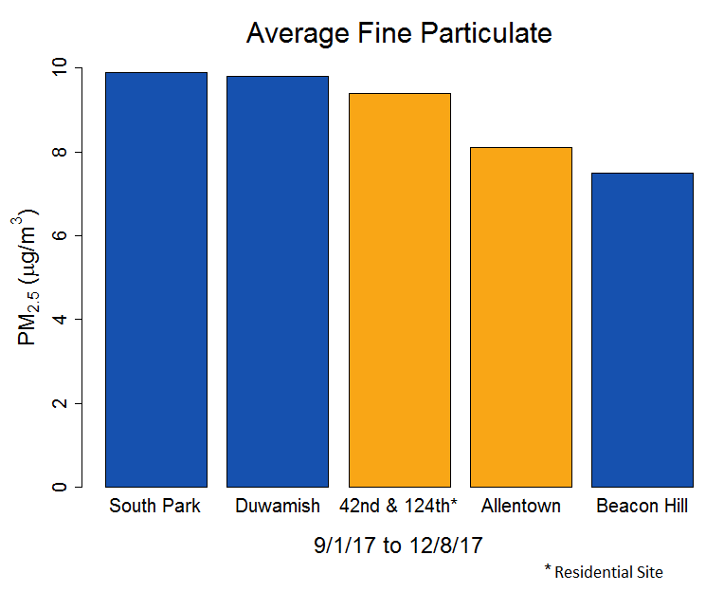
How do fine particle levels in Allentown compare to other Puget Sound urban areas?
The bar chart to the left shows the average concentration of fine particles from September 1st to December 8th for Allentown, Beacon Hill, Duwamish and South Park. In general, Allentown had fine particle levels similar to and slightly less than other sites in the Duwamish Valley. The residential site at 42nd Ave and 124th St had a higher level of fine particles than the air monitoring site in Duwamish Park on 44th Ave.
Where are ultrafine particle levels elevated?
The map to the right shows the spatial distribution of ultrafine particles across Allentown. This map is based on 6 bike rides on several different days. The map takes the data from each individual bike trip’s “snapshots in time.” The blue squares indicate below-average ultrafine particle levels, the yellow squares indicate average ultrafine particle levels, and the brown squares indicate higher ultrafine particle levels. Based on the data so far, ultrafine particle levels are most elevated near the entrance to the railyard. As we continue to do more rides through Allentown the pattern of ultrafine particles should become more representative.

How did we measure air pollution levels?
We measured fine particle pollution – a type of air pollution that is closely related to transportation (cars, trucks, etc.) and wood smoke. To see how fine particle levels differ throughout Allentown, we used the air monitoring station in Duwamish Park (located near 44th Ave) and three air monitors at residential homes in the neighborhood beginning in September 2017.

We also attached a portable air monitor to a bicycle and rode across Allentown to look at the levels of ultrafine particles across the neighborhood. The instruments set up at homes and on the bicycle aren’t perfect, but they are a helpful way to gather initial information and can be quickly deployed.

What are the health risks for fine and ultrafine particles?
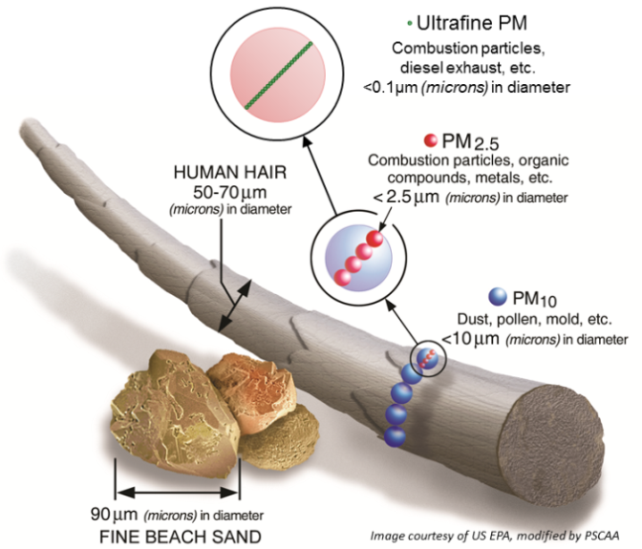
Fine particles (less than 2.5 microns in diameter, or “PM 2.5”) can reach the deepest part of your lungs. Decades of research have shown that fine particles can worsen respiratory diseases, such as asthma, cause heart attacks, strokes, and lead to premature death. These health impacts are greater for sensitive populations like children, the elderly, and people with pre-existing health conditions. Ultrafine particles are even smaller than fine particles (less than 0.1 microns in diameter). While not as much is yet known about the health effects of ultrafine particles, some studies suggest similar respiratory and cardiac impacts.

What’s next?
We plan to return to homes with air monitors to capture more data over the winter months. Air quality is typically worse in the winter due to both weather conditions as well as wood smoke from residences. We will then combine wintertime data with data above and publish and share a more complete analysis of air quality in the area in late spring of 2018.

