**Tukwila-Allentown Air Quality – 1st Update**

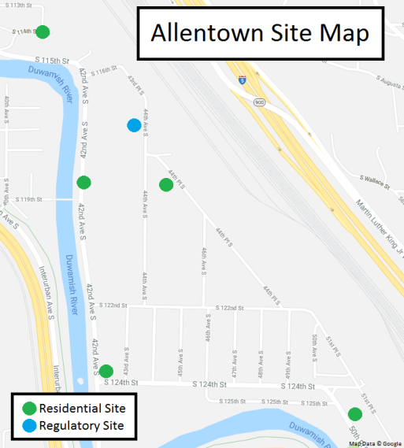**Goal:** To measure air quality levels in the Tukwila-Allentown neighborhood.

**What were some of the community’s questions?**

* Is there more air pollution near the railyard and 124th St than the rest of the neighborhood?
* Are air pollution levels roughly the same across Allentown?
* How do air pollution levels in Allentown compare to other Puget Sound urban areas?

**What we’ve learned so far:**

* Fine particle levels were higher near the intersection of 42nd Ave & 124th St and the air monitoring station in Duwamish Park compared to other sites in Allentown.
* Ultrafine particle levels vary across Allentown and seem to be higher near the entrance to the railyard.
* Fine particle levels in Allentown are similar to other places in the Puget Sound region. The monitor at 42nd Ave and 124th St had higher average fine particle levels than the air monitoring station on 44th Ave.

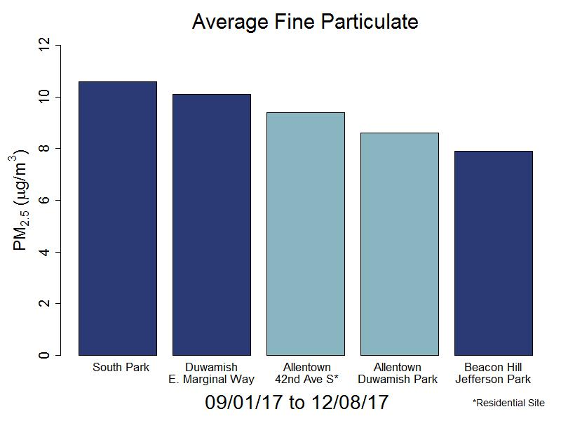 **How do air pollution levels in Allentown compare to other Puget Sound urban areas?**

The bar chart to the left shows the average level of fine particles (also known as PM 2.5) from September to December for Allentown, Beacon Hill, SODO and South Park. Fine particles are the type of air pollution we measure the most because of its health impacts (see back page for more information on this).

Based on the data so far, **fine particle levels in Allentown were similar to and slightly less than other sites in the Duwamish Valley.** Levels at all sites are below national health-based air quality standards. The residential site at 42nd Ave and 124th St had the highest level of fine particles in the neighborhood.

**How did we measure air pollution levels?**

We measured fine particle pollution – a type of air pollution that is closely related to transportation (cars, trucks, etc.) and wood smoke. To see how fine particle levels differ throughout Allentown, we used the air monitoring station in Duwamish Park (located near 44th Ave) and three air monitors at homes beginning in September 2017.

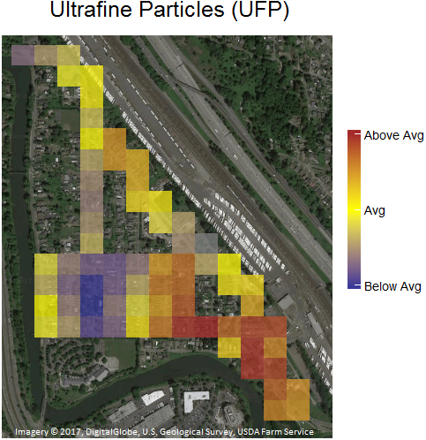We also attached a portable air monitor to a bicycle and rode across Allentown to look at the levels of ultrafine particles across the neighborhood. The instruments set up at homes and on the bicycle aren’t perfect, but they are a helpful way to gather information and can be set up quickly.

**Where are ultrafine particle levels higher?**

The map to the right shows the distribution of ultrafine particles across Allentown. This map is based on six bike rides on several different days. The map takes the data from each bike trip’s “snapshot in time.” The blue squares indicate areas that have ultrafine particle levels below the average in Allentown, the yellow squares indicate average ultrafine particle levels, and the brown squares indicate higher ultrafine particle levels.

Based on the data so far, ultrafine particle levels are highest near the entrance to the railyard. As we do more rides, the pattern of ultrafine particles should become clearer.

**What are the health risks for fine and ultrafine particles?**

Fine particles (less than 2.5 microns in diameter, also known as “PM 2.5”) can reach the deepest part of our lungs. Decades of research have shown that fine particles can worsen breathing and heart problems, such as asthma, cause heart attacks, strokes, and lead to premature death. These health impacts are greater for sensitive populations like children, the elderly, and people with pre-existing health conditions.



Ultrafine particles are even smaller than fine particles (less than 0.1 microns in diameter). While not much is yet known about the health risks of ultrafine particles, some studies suggest similar heart and breathing impacts.

**What’s next?**

We plan to return to homes with air monitors to over the winter months. Air quality is typically worse in the winter because of the weather conditions as well as wood smoke from residences. We will then combine wintertime data with the data above and share a more complete analysis of Allentown’s air quality in late spring of 2018.