**Downloading, Installing, and Running the SonicWall NetExtender Client for VPN**

These instructions are for downloading, installing, and running the SonicWall NetExtender client on a personal (non-agency) computer running Windows 7. The NetExtender client creates a secure (SSL) VPN tunnel between the remote computer and the agency’s SonicWall security device and internal network. Success using the NetExtender client is dependent on the quality and speed of the Internet connection, the network hardware (cable modem, router, WiFi) and the computer at the remote location. The SSL-VPN traffic between the remote computer and the SonicWall security device is sensitive to millisecond network traffic interruptions and delays that may not be noticeable when simply browsing the Internet. These interruptions can result in the SSL-VPN connection being dropped without warning. To minimize this behavior, it is recommended that the remote computer be directly connected to the remote router rather than using WiFi.

1) Download the latest version of NetExtender (v8.0.238) by clicking on this this link:

<http://dl.pscleanair.org/NetExtender/Windows/NetExtender.8.0.241.MSI>

* Depending on the browser you are using, you will be asked to run/save the file.  Save it.

**Example, Firefox:**

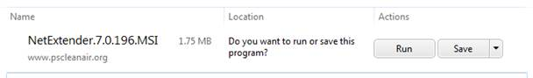

**Example, Internet Explorer:**



* The installation file will be saved to your **Downloads** folder (C:/users/*username*/downloads) by default.

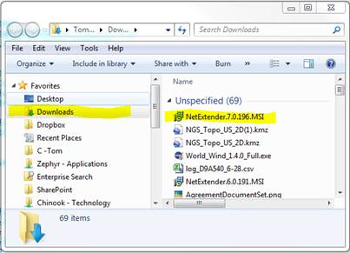

2) Install the NetExtender software you downloaded in Step #1

* Browse to the **Downloads** folder.
* Double-click on the **NetExtender.8.0.241.MSI** icon

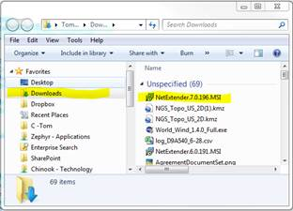

* Answer the remaining dialog boxes as shown:

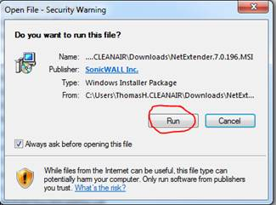

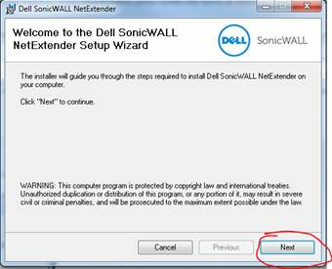

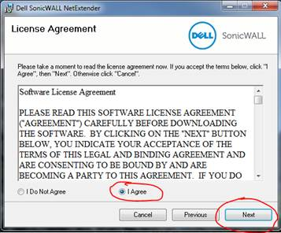

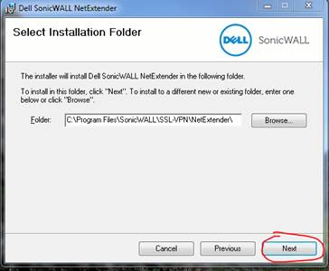

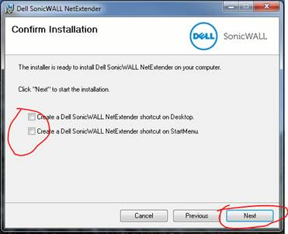

                ** If the User Account Control dialog box is displayed, click on **Yes**.

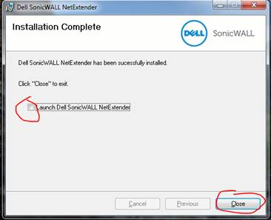

3) Run the NetExtender client to connect to the agency’s network .

* Double-click on the NetExtender icon in the taskbar.



* Enter the information highlighted in yellow and click on the **Connect** button.

(note, in the server name there is a colon between “pscleanair.org” and “4433”)

