King County Greenhouse Gas Emissions Inventory

A 2015 Update

October 2017

Prepared for King County, Washington

**Table of Contents**

Executive Summary 3

Introduction 3

2015 Geographic-Plus Inventory Findings 4

2015 Consumption-Based Inventory Findings 7

Acronyms 8

Introduction and Context 9

Roadmap of this Report 10

Geographic-Plus Inventory 11

Results 11

Data Sources 22

Key Differences between Past and Current Methodologies 25

Data Source Limitations 33

Data Sensitivity to Local Conditions 34

Sensitivity, by Sector 35

Consumption-Based Inventory 38

Methodology 38

Results 40

Discussion 46

Conclusion 54

Contribution Analysis 56

Conclusion and Future Considerations 57

References 58

# Executive Summary

## Introduction

To avoid the most serious impacts of climate change, deep reductions in greenhouse gases (GHG) emissions are needed. Quantifying sources of GHGs is a fundamental step toward reducing GHG emissions and tracking progress toward emission reduction targets. In 2014, the Growth Management Planning Council, the regional planning council which includes elected leaders from the 39 cities of King County and the Metropolitan King County Council, unanimously adopted ambitious shared near and long-term GHG reduction targets. King County further reaffirmed these targets with the adoption of its 2015 King County Strategic Climate Action Plan. The adopted targets are to reduce countywide sources of GHG emissions below 2007 levels 25% by 2020, 50% by 2030, and 80% by 2050. King County also committed to responsibility for periodic assessment and reporting of progress towards the targets.

This report provides a 2015 update of the county’s communitywide emissions and compares results to newly updated inventories for 2003, 2008, and 2010. The report also quantified 2007 countywide emissions for use in comparison towards adopted targets.

As science and policy have progressed, relevant and accepted methodologies for producing a GHG inventory have changed. The *U.S. Community Protocol for Accounting and Reporting Greenhouse Gas Emissions* (“Community Protocol”) has emerged as a consistent, U.S.-specific framework for quantifying GHG emissions at the community-scale. This 2015 inventory for King County follows the Community Protocol. To facilitate comparison among years, past data were also updated to reflect compliance with the U.S. Community Protocol.

This report includes two distinct inventories: a “geographic-plus” inventory and a “consumption-based” inventory. The geographic-plus inventory primarily estimates the annual GHG emissions released within community boundaries, but also includes emissions from electricity generated outside of King County but consumed within the County. The consumption-based inventory accounts for the GHG emissions associated with the consumption of goods and services within the community, regardless of where these goods were produced.

## 2015 Geographic-Plus Inventory Findings

* King County 2015 geographic-plus greenhouse gas emissions totaled 21.4million metric tons of carbon dioxide equivalent (MgCO2e), representing an estimated 4% increase compared to the 2007[1] baseline year and a 3% increase compared to 2008 emissions (Figure 1 and Figure 2).
* Per person or per-capita emissions declined by an estimated 6.6% from 2007 compared to 2015 and 6.1% from 2008 to 2015. When including both core and supplementary emissions sectors, the average King County resident emitted 11.2 MgCO2e in 2007, 11.1 MgCO2e in 2008, and 10.4 MgCO2e in 2015. Total population in King County increased 11% from 1.8 million residents in 2007 to 2.1 million residents in 2015 (Figure 4).
* “Core emissions” from residential and commercial energy use and from on-road transportation sources stabilized between 2010 and 2015 (Figure 3).
* In 2015, King County’s largest sources of geographic-plus based greenhouse gas emissions are the built environment (63%) and transportation (35%).
* The largest increases in emissions from 2008 to 2015 were in the residential and commercial electricity sectors (0.16 and 0.27 million MgCO2e increase, respectively, equivalent to 7% and 10% increases). The largest decreases were due to changes in residential natural gas and on-road passenger vehicle emissions (0.26 and 0.11 million MgCO2e decrease, respectively, equivalent to 14% and 2% decreases).
* Emissions from solid waste (1%), wastewater (<1%), and agriculture (1%) are a small part of overall GHG emissions in King County.

Figure . Sources of geographic-plus based GHG emissions for King County in 2015, excluding supplemental sources (total = 21.4 million MgCO2e).

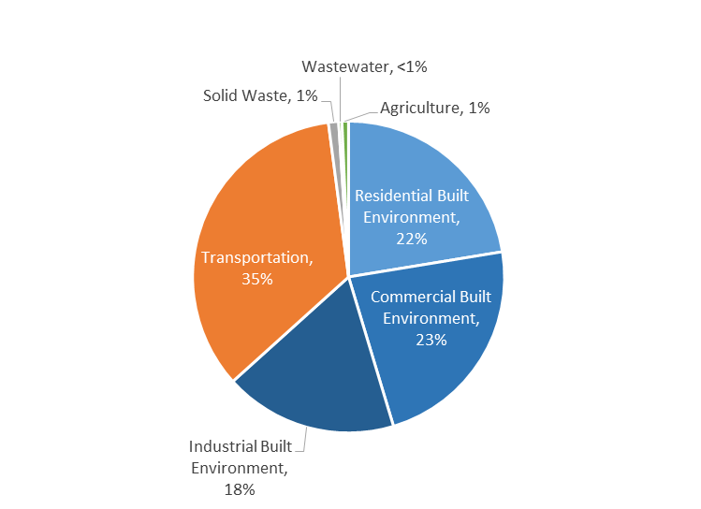

Figure . Sources of residential and commercial built environment GHG emissions for King County in 2015 (total = 9.7 million MgCO2e).

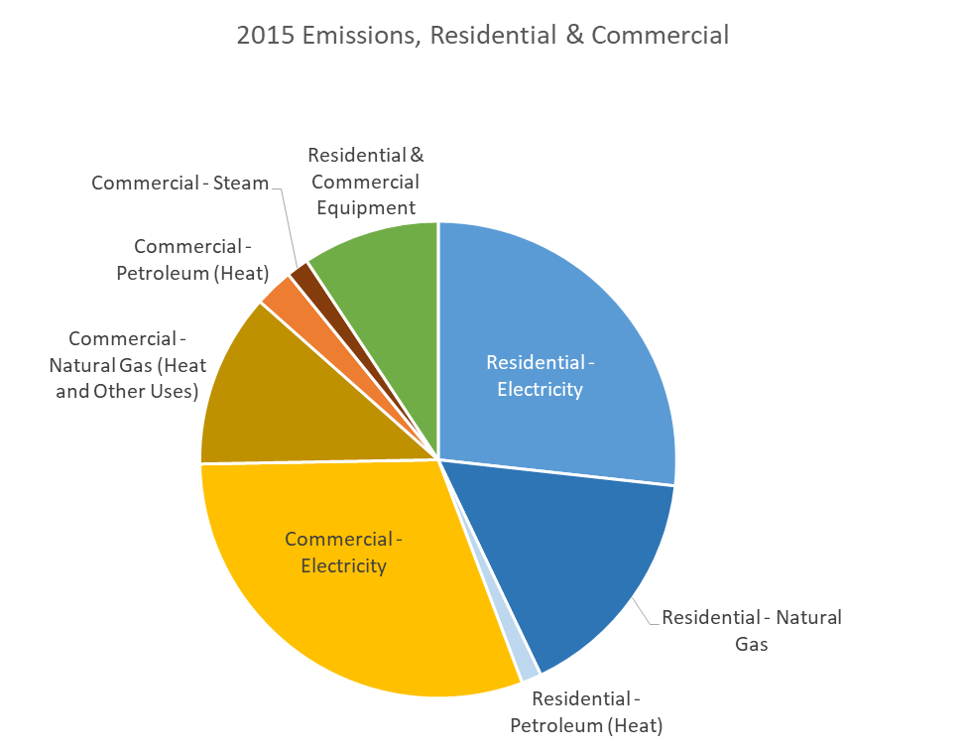

Figure . Core GHG emissions for King County over time.

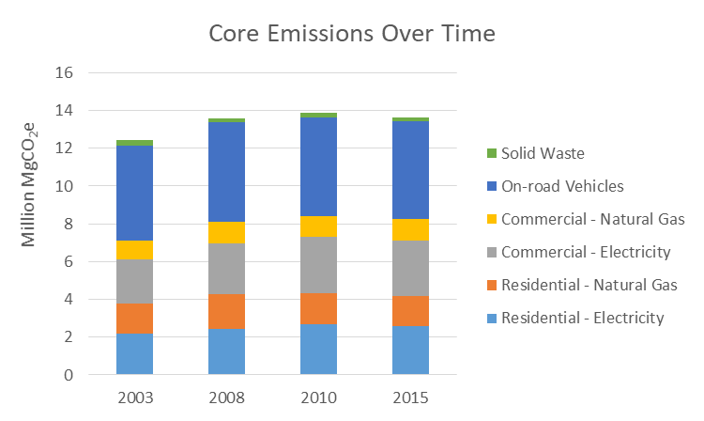

Figure . Geographic-plus based GHG emissions by sector for King County.

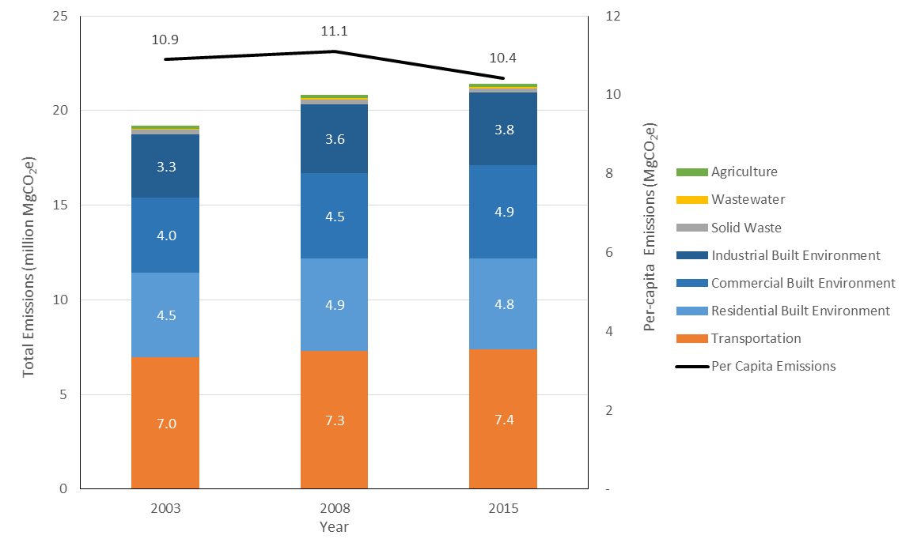

## 2015 Consumption-Based Inventory Findings

* King County 2015 consumption-based greenhouse gas emissions totaled 58.2 million MgCO2e, slightly less than three times the emissions within the geographic-plus boundary.
* Between 2008 and 2015, total consumption-based emissions increased by 5.8%, while King County population increased by 13%.
* 41.2 million MgCO2e, or 71%, of the consumption-based emissions are due to households’ consumption of goods and services; the remainder is due to government and to business investment spending.
* 41.8 million MgCO2e, or 72%, of the consumption-based emissions are pre-consumer, due to the production and transport of the goods or services.
* In 2015, King County’s largest sources of consumption-based greenhouse gas emissions were vehicles & vehicle parts (21%), appliances including HVAC (14%) and food & beverages (13%).
* Relative to 2005, the biggest increases in emissions were attributed to services (+1.41 million MgCO2e), vehicles & vehicle parts (+977 million MgCO2e) and transportation services (+785 million MgCO2e).

Figure . Causes of consumption-based GHG emissions for King County in 2015 (total = 58.2 million MgCO2e).



# Acronyms

|  |  |
| --- | --- |
| BOD | Biochemical oxygen demand (a metric of the effectiveness of wastewater treatment plants) |
| EIA | United States Energy Information Association |
| EPA | United States Environmental Protection Agency |
| CO2e | Carbon dioxide equivalents |
| GHG | Greenhouse gas (limited to CO2, CH4, N2O, and fugitive gases in this inventory |
| MOVES | Motor Vehicle Emission Simulator model (developed by EPA to quantify emissions from mobile sources) |
| NONROAD | (Developed by EPA to quantify non-road mobile emissions) |
| ODS | Ozone depleting substance |
| PSCAA | Puget Sound Clean Air Agency |
| PSE | Puget Sound Energy |
| PSRC | Puget Sound Regional Council |
| SCL | Seattle City Light |
| SPU | Seattle Public Utilities |
| TCR | The Climate Registry |
| USDA | United States Department of Agriculture |
| WARM | Waste Reduction Model (model developed by EPA to quantify solid waste emissions) |
| WSDOT | Washington Department of Transportation |
| VMT | Vehicle Miles Travelled |
| MgCO2e | Megagrams of carbon dioxide equivalent |

# Introduction and Context

Greenhouse gas inventories allow communities to account for sources and quantities of GHG emissions generated by community activities. This report includes two distinct inventories: a “geographic-plus” inventory and a “consumption-based” inventory. The geographic-plus inventory estimates the annual GHG emissions released within community boundaries and due to community activities, such as energy consumption and waste disposal. The consumption-based inventory accounts for the GHG emissions associated with the goods and services consumed within the community.

Table . Inventory comparison.

|  |  |
| --- | --- |
| Geographic-Plus | Consumption-based |
| Emissions associated with all activities that occur inside the county, “plus” all electricity GHG emissions, even if the electricity is generated outside King County. | Embodied emissions associated with production, transportation, use and disposal of goods, food, and services consumed in King County. |

The **geographic-plus inventory** estimates GHG emissions produced by activities of the King County community, including emissions resulting from community energy use; wastewater and solid waste processing; and terrestrial carbon lost due to land use development. It includes both “in-boundary” emission *sources*—any physical process inside the jurisdictional boundary that releases GHG emissions—and activities resulting in GHG emissions. For example, it includes emissions associated with the in-county *production* of food and goods, regardless of where those goods are consumed, such as from a manufacturer located within King County that produces goods for export.

The **consumption-based inventory** provides an inventory of the GHG emissions associated with *consumption* of food and goods within the community, regardless of where the goods were produced. For example, the consumption-based inventory would not include GHG emissions associated with the production of goods from a local manufacturer that are consumed entirely outside the community, but would include GHG emissions associated with the production of goods manufactured in another community but consumed within King county. Thus, the consumption-based inventory accounts for different, but related sources of emissions associated with community activities.

The geographic-plus and consumption-based inventories provide insights about different GHG emission footprints of a community. For example, a community may consume electricity generated from low-emission sources, but also consume goods produced in another community with high-emission energy. The two inventories can account for these differences to paint a comprehensive picture of community emissions.

King County previously conducted geographic-plus inventories for 2003 and 2008 and a limited-scope “core” inventory in 2010 (Figure 4). This inventory report includes two major updates 1) a 2015 geographic-plus inventory that follows the U.S. Community Protocol and 2) updated 2003, 2008, and 2010 inventories that are compliant with the U.S. Community Protocol and comparable to the 2015 inventory.

Figure . King County greenhouse gas inventory timeline.

## Roadmap of this Report

This report is organized into the following three sections to assess GHG emissions associated with King County:

* A **Geographic-Plus Inventory** describes methodologies and results for the geographic-plus inventory.
* A **Consumption-Based Inventory** section presents methodologies and results from the consumption-based inventory.
* A **Contribution Analysis** section that explores drivers of King County emission trends.
* The report concludes with sections that summarize **future considerations** for greenhouse gas emission quantification and reporting.

# Geographic-Plus Inventory

The geographic-plus inventory quantifies the release of GHG emissions from activities within King County’s geographic boundary, including from transportation, buildings, industrial processes, waste, water use, and agriculture. The “plus” portion expands this scope to include emissions produced by electricity generation outside of the community but consumed by in-county activities.

## Results

### Overview

* King County 2015 geographic-plus greenhouse gas emissions totaled 21.4million metric tons of carbon dioxide equivalent (MgCO2e), representing an estimated 4% increase compared to the 2007[2] baseline year and a 3% increase compared to 2008 emissions (Figure 1 and Figure 2).
* Per person or per-capita emissions declined by an estimated 6.6% from 2007 compared to 2015 and 6.1% from 2008 to 2015. When including both core and supplementary emissions sectors, the average King County resident emitted 11.2 MgCO2e in 2007, 11.1 MgCO2e in 2008, and 10.4 MgCO2e in 2015. Total population in King County increased 11% from 1.8 million residents in 2007 to 2.1 million residents in 2015 (Figure 4).
* “Core emissions” from residential and commercial energy use and from on-road transportation sources stabilized between 2010 and 2015 (Figure 3).
* In 2015, King County’s largest sources of geographic-plus based greenhouse gas emissions are the built environment (63%) and transportation (35%).
* The largest increases in emissions from 2008 to 2015 were in the residential and commercial electricity sectors (0.16 and 0.27 million MgCO2e increase, respectively, equivalent to 7% and 10% increases). The largest decreases were due to changes in residential natural gas and on-road passenger vehicle emissions (0.26 and 0.11 million MgCO2e decrease, respectively, equivalent to 14% and 2% decreases).
* Emissions from solid waste (1%), wastewater (<1%), and agriculture (1%) are a small part of overall GHG emissions in King County.

Figure . Sources of geographic-plus based GHG emissions for King County in 2015, excluding supplemental sources (total = 21.4 million MgCO2e).



Figure . Sources of residential and commercial built environment GHG emissions for King County in 2015 (total = 9.7 million MgCO2e).



Figure . Core GHG emissions for King County over time.

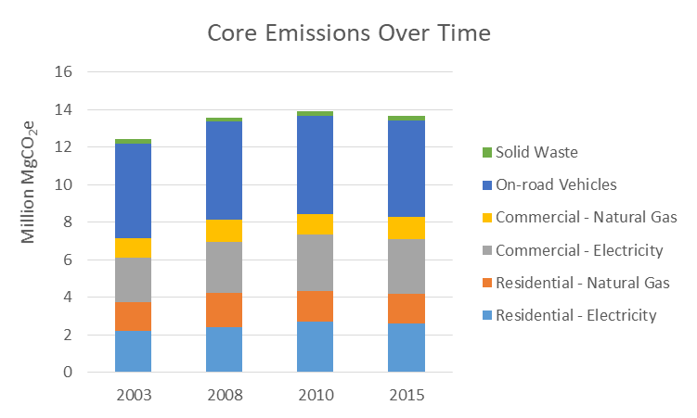

Figure . Geographic-plus based GHG emissions by sector for King County.



Table . King County GHG emissions by sector (MgCO2e).



Table . King County GHG emissions by sector (percentage of core and expanded production MgCO2e).

|  |  |  |  |  |  |
| --- | --- | --- | --- | --- | --- |
| **GHG Emissions by Sector (% of Total)** | | | **2003** | **2008** | **2015** |
| **Built Environment** | | | **61.1%** | **62.7%** | **63.3%** |
|  | **Residential** |  | **23.2%** | **23.4%** | **22.4%** |
|  |  | Electricity | 11.4% | 11.7% | 12.1% |
|  |  | Natural Gas | 8.2% | 8.8% | 7.3% |
|  |  | Petroleum (Heating) | 1.5% | 1.0% | 0.6% |
|  |  | Petroleum (Non-road equipment) | 2.1% | 2.0% | 2.3% |
|  | **Commercial** |  | **20.7%** | **21.7%** | **22.9%** |
|  |  | Electricity | 12.2% | 12.9% | 13.8% |
|  |  | Natural Gas (Heat and Other) | 5.4% | 5.6% | 5.4% |
|  |  | Natural Gas (Equipment) | 0.4% | 0.4% | 0.7% |
|  |  | Petroleum (Heat and Other) | 1.1% | 1.2% | 1.2% |
|  |  | Petroleum (Equipment) | 0.9% | 0.8% | 1.2% |
|  |  | Steam | 0.8% | 0.9% | 0.7% |
|  | **Industrial** |  | **17.2%** | **17.5%** | **18.0%** |
|  |  | Electricity | 3.2% | 2.8% | 2.9% |
|  |  | Process emissions | 2.3% | 2.1% | 1.6% |
|  |  | Stationary combustion | 8.5% | 8.2% | 8.5% |
|  |  | Fugitive gases | 3.2% | 4.3% | 4.9% |
| **Transportation and Other Mobile Sources** | | | **36.3%** | **35.0%** | **34.6%** |
|  | **On-road vehicles** |  | **32.1%** | **30.7%** | **29.7%** |
|  |  | Passenger vehicles | 26.1% | 25.2% | 24.0% |
|  |  | Freight and service vehicles | 5.3% | 4.9% | 4.9% |
|  |  | Transit vehicles | 0.7% | 0.6% | 0.7% |
|  | **Freight and passenger rail** |  | **0.3%** | **0.4%** | **0.4%** |
|  | **Marine vessels** |  | **0.7%** | **0.7%** | **0.9%** |
|  | **Off-road vehicles and other mobile equipment** |  | **0.5%** | **0.5%** | **0.6%** |
|  | **Commercial airport** |  | **2.7%** | **2.8%** | **3.1%** |
| **Solid Waste** | | | **1.4%** | **1.2%** | **1.1%** |
|  | Generation and disposal of solid waste |  | 1.4% | 1.2% | 1.1% |
| **Water and Wastewater** | | | **0.3%** | **0.3%** | **0.3%** |
|  | Potable water process emissions |  | 0.0% | 0.0% | 0.0% |
|  | Wastewater process emissions |  | 0.3% | 0.3% | 0.3% |
| **Agriculture** | | | **0.9%** | **0.8%** | **0.7%** |
|  | Domesticated animal production |  | 0.4% | 0.4% | 0.4% |
|  | Manure decomposition and treatment |  | 0.5% | 0.5% | 0.3% |
| **Other Emission Sectors** | | | **N/A** | **N/A** | **N/A** |
|  | Soil management |  | N/A | N/A | N/A |
|  | Residential development |  | N/A | N/A | N/A |
| **Total Emissions** | | |  |  |  |
|  | **Core & Expanded Production** |  | **100.0%** | **100.0%** | **100.0%** |
|  |  | **Core** | **71.0%** | **71.2%** | **70.1%** |
|  |  | **Expanded: Production** | **29.0%** | **28.8%** | **29.9%** |
|  |  | **Expanded: Supplementary** | **N/A** | **N/A** | **N/A** |

Table . Per-capita GHG emissions for King County between inventory years.



Figure . King County 2015 per-capita GHG emissions compared to other jurisdictions.[3]

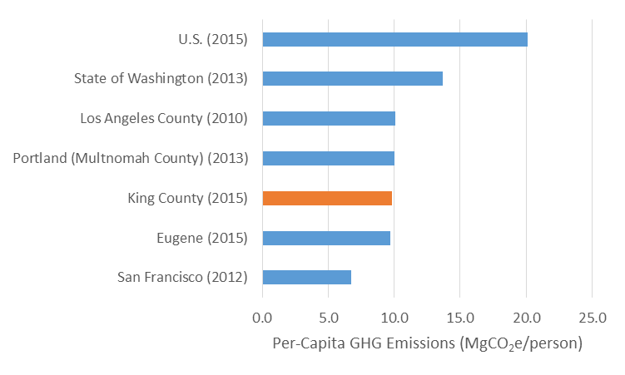

### Residential and Commercial Buildings

Emissions from the residential and commercial built environment resulted in the following key trends and findings:

* In 2015, the built environment accounted for 62% of communitywide emissions. Emissions from commercial and residential buildings accounted for most of those emissions and 48% of all emissions.
* Changes in energy demand and fuel mix in the commercial and residential sectors led to an 8% increase in commercial and 2% decrease in residential energy emissions compared to 2008. Commercial increases can be attributed largely to increases in electricity consumption. Overall, however, natural gas and electricity use has declined in King County since 2008.
* Process emissions, a significant portion of overall industrial emissions, have decreased 19% since 2008.

King County’s electricity and natural gas are delivered through two energy providers: Seattle City Light (SCL) and Puget Sound Energy (PSE). Both providers generate electricity primarily through hydroelectricity, however other sources such as coal and natural gas are also used—especially when hydroelectric capacity is low. Although non-fossil fuel sources constituted a significant portion of both SCL (97%) and PSE (33%) 2015 fuel mix, relative proportions of fuels and resulting emissions factors fluctuate through time (see Figure 9). This change in King County’s electricity utilities’ fuel mixes have resulted in a fluctuation in the emissions produced per unit of energy delivered over time.

King County’s electricity is also connected to the regional grid, which has its own emissions profile. To put King County’s emissions in context, a sensitivity analysis was run per the recommendations of the U.S. Community Protocol to compare the utility-specific emissions profile with that of the regional grid. Results are shown in Figure 9. In general, the utility-specific emissions profiles out-performed (generated fewer GHG emissions) the regional emission factor.

Figure . Sources of residential (left) and commercial (right) GHG emissions in 2015.

|  |  |
| --- | --- |
| **Residential Emissions (MgCO2e)** | **Commercial Emissions (MgCO2e)** |
|  |  |

Figure . Emission sources from the built environment from 2003 to 2015.

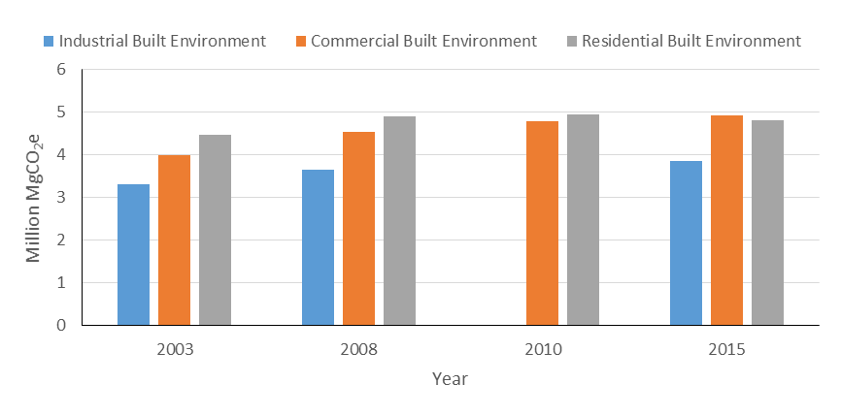

Table . Electricity GHG emissions (MgCO2e) generated to power residential, commercial, and industrial consumers by SCL and PSE compared to a regional (eGRID) emission factor for 2015. The performance ratio is the ratio of utility-specific emissions relative to the eGRID-calculated equivalent.

|  |  |  |  |  |
| --- | --- | --- | --- | --- |
|  | Residential | Commercial | Industrial | Performance Ratio |
| PSE | 2,530,656 | 2,831,986 | 582,038 | 1.16 |
| PSE-eGRID equivalent | 2,185,949 | 2,447,935 | 502,757 |  |
| SCL | 66,420 | 123,831 | 29,576 | 0.06 |
| SCL-eGRID equivalent | 1,211,722 | 2,063,026 | 491,888 |  |

Figure . Utility-specific and eGRID (NWPP) electricity emissions factors for King County electricity utilities.

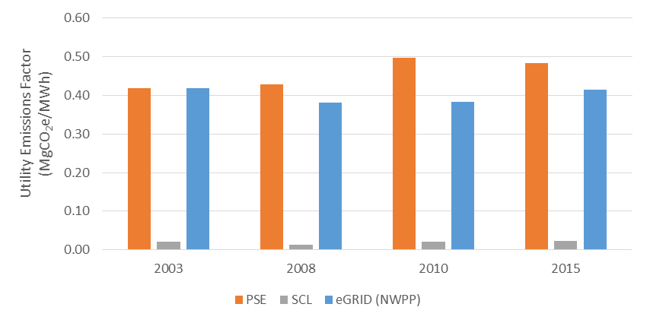

Figure . Comparison of utility-specific and eGRID-derived (NWPP) electricity emissions for King County.

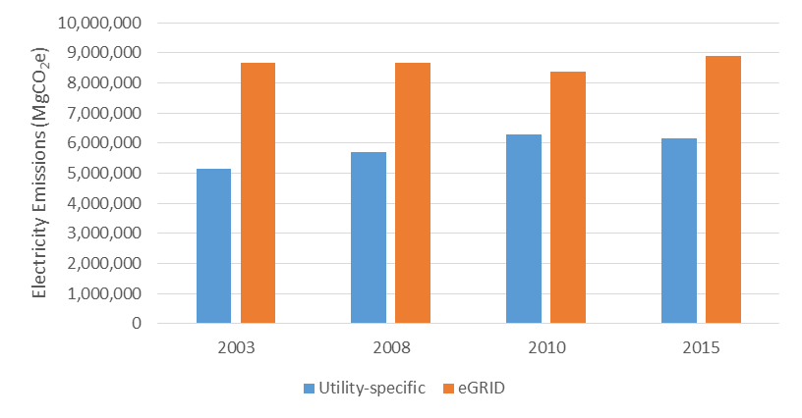

### Transportation

Transportation accounted for 35% of GHG emissions in 2015, and was the largest source of emissions after the built environment. Total transportation emissions have remained relatively steady since 2008 (Figure 12), and have declined by 8% per capita within that time period. Most transportation emissions in 2015 stemmed from passenger vehicles (76%).

Figure . GHG emission sources for transportation in 2015.

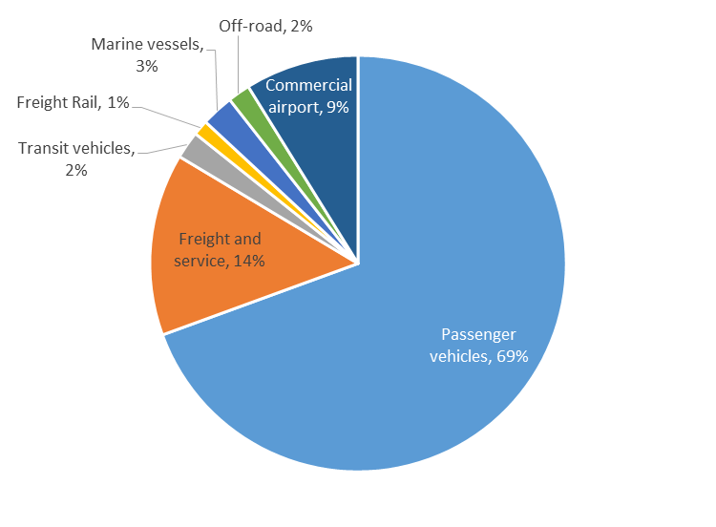

### Industry

Industrial GHG emissions increased 6% from 2008 to 2015. Emissions from electricity in the industrial sector have increased 2% to about 600,000 MgCO2e in 2015. Process emissions have declined. Emissions from stationary combustion increased 11% since 2008, even as electricity demand increased within the industrial sector. Fugitive gas emissions increased 18% between 2008 and 2015.

Figure . Sources of industrial emissions for King County in 2015 (total = 3.8 million MgCO2e).

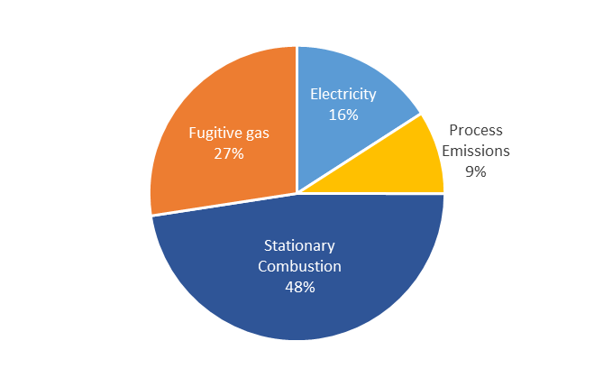

### Solid Waste

Emissions from solid waste disposal have declined in King County since 2003 despite increasing population (Figure 16). Since 2010, emissions have declined 5%, totaling 225,600 MgCO2e in 2015. Per-capita emissions have decreased 9% over that same timeframe. These estimates do not include the carbon sequestration benefits of solid waste disposal—only the GHG emissions.

Figure . GHG emissions from waste disposal.

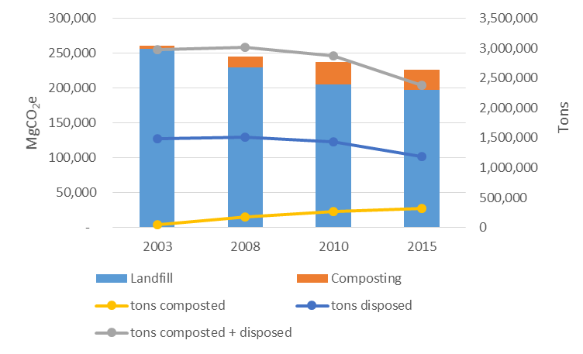

[enter brief trend for landfill emissions]

### Water and Wastewater

Potable water in King County is sourced from the Cedar River and Tolt watersheds. Within a community, emissions from potable water treatment and conveyance and wastewater treatment are dependent on the number of people served and the fuel mix of the energy source. Total emissions from potable water used in King County were under 1,000 MgCO2e in 2015. Potable water related emissions come from energy use in water treatment and distribution. Overall, potable water is an extremely small source in King County.

We estimate that wastewater emissions have increased by 9% from 2008 to 2015, and have been relatively stable on a per-capita basis over that period. King County supplies biosolids as fertilizer for several Washington operations, which likely reduces the need for artificial fertilizer. The GHG benefits associated with biosolid fertilizer applications are outside the scope of this inventory.

### Agriculture and Land Use Change

Agriculture accounts for only about 1% of GHG emissions in King County, and this relative contribution has remained steady over time. Emissions are primarily derived from enteric digestion of ruminants and manure. Enteric emissions are increasing despite declining per-cattle emissions, indicating an increase in the county’s animal population. During the same time, manure emissions declined 31%.

Emissions from soil management increased 13%, but remain very small compared to other sources. In 2015, soil management released 9,400 MgCO2e.

We estimate that emissions from land use change has declined by 14% due to a decline in the number of building permits issued and, consequently, acres of land cleared for new residential construction over that time period.

## Data Sources

Conducting the inventory involved acquiring the following data, summarized in Table 2 and detailed in the following sections:

* **Activity data** that quantifies levels of activity that generate GHG emissions, such as miles traveled and kWh of electricity consumed.
* **Emission factors** that translate activity levels into emissions (e.g., MgCO2e per kWh).

Table . Key data sources for King County’s 2015 geographic-plus inventory.

| Sector | Activity | Emission Factors |
| --- | --- | --- |
| Transportation (Road) | * Daily vehicle miles traveled (Puget Sound Regional Council) | * EPA MOVES2014a model |
| Transportation (Transit) | * King County Metro and Sound Transit fuel use | * US EPA (U.S. Environmental Protection Agency, 2015) |
| Transportation (Air) | * Jet fuel and aviation gas consumed at SeaTac airport and Boeing Field | * US EPA (U.S. Environmental Protection Agency, 2015) |
| Transportation (Marine) | * Puget Soound Maritime Air Emissions Inventory (Puget Sound Clean Air Agency, 2012) * Washington State Ferries route statements (Washington State Department of Transportation, 2015) | * EPA NONROAD * US EPA (U.S. Environmental Protection Agency, 2015) |
| Buildings and Industry (Electricity) | * kWh consumption (SCL and PSE) | * Utility fuel mix (Washington State Department of Commerce, 2015) * SCL reported emission factors (The Climate Registry, 2015) |
| Buildings and Industry (Natural Gas and Oil) | * Gas use (PSE provided by King County) * Oil use (U.S. Energy Information Administration, 2015) | * Carbon content of natural gas and oil (U.S. Environmental Protection Agency, 2015) |
| Fugitive Gases | * Substitution of ozone-depleting substances * SF6 emissions from electric utility switchgear insulation | * US EPA (U.S. Environmental Protection Agency, 2015) * IPCC |
| Solid Waste | * Landfill gas generation * Tons disposed and composted (King County, 2017) | * US EPA WARM v14 model * Customized landfill methane capture rates (Coven, et al., 2014) |
| Wastewater | * Wastewater treatment rates from King County and Seattle Public Utilities | * National wastewater factors   (Local Governments for Sustainability USA, 2013) |
| Water | * Quantity and use provided by Seattle Public Utilities | * Energy provider emission factor |
| Agriculture | * Acres of cropland and number of livestock (U.S. Department of Agriculture, 2014) | * Emissions per animal or per acre (U.S. Environmental Protection Agency, 2015) |
| Land Use Change | * Acres of land cleared for development (King County Assessor’s database) | * Average carbon stocks in King County as assessed by the University of Washington |

### Transportation

* **Vehicle miles traveled (VMT)** were derived from Puget Sound Regional Council and accounted for all mileage within the county boundary regardless of trip origin or destination. The PSRC then used emission factors derived originally from the EPA MOVES model and modified those factors to reflect regional vehicle fleet age and fuel composition. The PSRC data reported overall emissions for passenger vehicles (cars, motorcycles, light trucks), medium trucks, and heavy trucks.
* We acquired **fuel consumption** data for Metro (King County’s bus transit service) and Sound Transit (a regional transit service that serves King County) from the National Transit Database from the Federal Transit Administration.
* We obtained **jet and aviation fuel data** for Boeing Field from King County and for SeaTac airport from the Port of Seattle.
* **Ferry** fuel data is reported annually by WSDOT for each ferry route. We used the fiscal year that most closely associated with our year of interest.
* The Puget Sound Clean Air Agency published a 2011 report on maritime air emissions, which we used to enumerate 2015 **freight rail and port** emissions. This report is currently being updated to reflect more recent emissions. We recommend that King County update its inventory values when that report is available.
* Emissions from **pleasure boats** and other small-engine recreational vessels were obtained through EPA NONROAD modeling of King County.

### Buildings and Energy

* Data on **electricity** and **natural gas** use were provided by the two King County utilities: SCL and PSE.
* **Residential heating fuel** consisted of natural gas, of which the data were provided by PSE, and heating oil, provided by EIA.
* Other residential emissions were calculated from the EPA NONROAD 2008 model output. Emissions include common non-road equipment, often for gardening and landscaping purposes, such as lawnmowers.
* **Commercial heating** is provided through natural gas, and steam from Enwave, a Seattle steam company that heats approximately 200 commercial downtown buildings. Enwave provides emissions data to the PSCAA.
* Additional commercial non-road sources were calculated with the EPA NONROAD 2008 model. These nonroad sources include fuel used for commercial landscaping and non-flight equipment at airports.
* **Industrial process** emissions are recorded by the PSCAA, which provided data on large sources of emissions from industry.
* Data on **fugitive refrigerant** emissions at regional scales is scarce. A nationally reported number by the EPA was used to scale to King County.
* PSE provided data on **natural gas consumption**, and the EIA provided data on **industrial oil**. We obtained emission factors for fuels from the EPA (U.S. Environmental Protection Agency, 2015).
* We calculated an emissions factor for PSE using the fuel mix reported in the annual Fuel Mix Disclosure reporting conducted by the Washington State Department of Commerce. SCL reports an emissions factor through The Climate Registry (TCR), which we used for all years except 2003, which predated TCR. For a 2003 SCL emissions factor, we used the fuel mix report (Washington State Department of Commerce, 2015).

### Solid Waste

* We used King County waste composition data, along with emissions factors from the EPA WARM v14 model, to calculate emissions from **waste disposal and composting**. Landfill emissions assumed 90% and 75% landfill gas capture rates for King County and Seattle waste, respectively.

### Wastewater

* Wastewater emission calculations required data from King County **wastewater treatment plants**, provided by facility engineers and publicly available documents.

### Potable Water

* **Potable water emissions** required data on water use, publicly available from Seattle Public Utilities, and energy use estimates provided by the U.S. Community Protocol.

### Agriculture

* The USDA provides publicly available data on the number of animals by county. The EPA provides national-level **animal enteric and manure** emission factors, and state-level emissions factors for cattle.

### Land Use

* The King County Assessor’s office publicly provides land use data for King County, which we used to calculate the emissions associated with **new development** in 2015.

## Key Differences between Past and Current Methodologies

This 2015 inventory update was conducted in adherence with the U.S. Community Protocol. See the text box on the following page for more information on this protocol and how it compares to other available protocols.

Several methodological differences between the current inventory and previous inventories led to notable changes in GHG emissions reported (see Table 3). For example, the current inventory includes methane (CH4) and nitrous oxide (N2O) emissions from fuel combustion. Previously, only emissions from carbon dioxide were included in combustion emission calculations, with the exceptions of methane emissions from agriculture and waste, and fugitive gases from industry. The current inventory includes updated PSE and SCL emission factors, which led to noticeably different building emissions compared to the previous methodologies. In the past, nonroad vehicle emissions were calculated by multiplying nonroad activity from the EPA NONROAD model with fuel-specific emission factors. The current inventory uses both activity and emission factors from the NONROAD model, which led to an increase in nonroad emissions for most categories.

**The U.S. Community Protocol**

The Community Protocol was built to provide easily applicable and accurate community-level estimates of GHG emissions. This protocol provides a consistent framework in which to compare protocols from a geographic boundary across time. The U.S. Community Protocol was designed for community-scale GHG accounting, making it a valuable tool for counties and cities, and an appropriate choice for King County. The Community Protocol is widely used, understood, and respected.

This inventory follows the Community Protocol methodology, and deviates from its stated methods only when more precise, local data is available, per the Community Protocol recommendations. The Local Governments for Sustainability (ICLEI) created the U.S. Community protocol in 2013. The U.S. Community Protocol requires, at a minimum, reporting of the following five activities: 1) Use of electricity by the community 2) Use of fuel in residential and commercial stationary combustion equipment 3) On-road passenger and freight motor vehicle travel 4) Use of energy in potable water and wastewater treatment and distribution 5) Generation of solid waste by the community. Other protocols, such as the Global Protocol for Community-scale GHG Emissions (GPC) are also commonly used. Whereas the GPC focuses primarily on the reporting and categorical requirements of an inventory, the U.S. Community Protocol provides specific methodologies, and often emission factors, to calculate different emissions sources.

This inventory calculates emissions associated with the five activities required of the U.S. Community Protocol, as well as other activities calculated in prior inventory years. The first two activities (community electricity use and stationary fuel combustion) are presented together within the “Residential and Commercial Buildings” and “Industry” sections of this report.

Additionally, the GPC includes consumption-based emissions, and some sinks, whereas the U.S. Community Protocol does not include sinks. Carbon sinks refer to processes that take greenhouse gases out of the atmosphere. By not accounting for sinks, the U.S. Community Protocol can over-represent the net GHG emissions, and allows for some societal goods, such as waste composting, to be perceived negatively. However, other sinks, such as a landfilling, could be perceived positively as a GHG sink, even though increased landfilling of waste is generally not considered a societal good.

Table . Brief methodological outline of previous inventories and this report.

| Sector | Methodology for previous inventories | Methodology update as part of this report for all past inventory years |
| --- | --- | --- |
| **Transportation (Road Vehicles)** | * VMT from Puget Sound Regional Council (PSRC) data * National emission factors (U.S. Environmental Protection Agency, 2008) | * Emissions calculated by PSRC as a function of VMT, fuel mix, fleet age, and EPA MOVES2014a emission factors * Inclusion of CH4 and N2O |
| **Transportation (Transit)** | * Transit fuel data used to determine emissions | * No change to transit |
| **Transportation (Air)** | * Landing-takeoff (LTO) emissions for King County airport * King County leisure/business travel emissions for SeaTac | * Only included LTO emissions for both King County and SeaTac * King County resident/business air travel emissions moved to a separate supplemental category |
| **Transportation (Marine)** | * Per-route, per-vessel ferry use (no source) * Freight emissions scaled with freight tonnage   (Puget Sound Clean Air Agency, 2012) | * Ferry fuel use (Washington State Department of Transportation, 2015) multiplied by diesel emission factors (U.S. Environmental Protection Agency, 2015) * NONROAD model outputs of harbor craft |
| **Transportation (Freight)** | * Freight emissions (Puget Sound Clean Air Agency, 2012) scaled to year’s tonnage | * No change |
| **Buildings and Industry (Electricity)** | * Puget Sound Energy (PSE) and Seattle City Light (SCL) emission factors calculated using fuel mix reports to derive emissions from fuel combustion (Washington State Department of Commerce, 2015) | * Inclusion of CH4 and N2O emission factors to fuel mix * TCR-based emission factor for SCL (The Climate Registry, 2015) * TCR-based methodology for PSE emission factor * Accounted for transmission losses |
| **Buildings and Industry (Natural Gas and Oil)** | * Quantity of natural gas and oil with emission factor (U.S. Environmental Protection Agency, 2015) * Mobile road emission factors (U.S. Environmental Protection Agency, 2008) applied to NONROAD fuel use data | * Inclusion of CH4 and N2O, quantity of natural gas and oil with EPA emission factors (U.S. Environmental Protection Agency, 2015) * NONROAD emission factors applied to NONROAD fuel use data (U.S. Environmental Protection Agency, 2015) |
| **Fugitive gases (ODS substitutes and switchgear insulation SF6)** | * EPA ODS tool * Scaled countywide SF6 values | * National ODS substitutes value scaled to region by population (U.S. Environmental Protection Agency, 2015) * Utility-specific SF6 emissions values |
| **Waste** | * Waste characterization (King County, 2017) and EPA WARM v8 emission factors | * Waste characterization (King County, 2017) and updated EPA WARM v14 emission factors * Included composting emissions |
| **Wastewater** | * Included biogas emissions | * Included biogas emissions, BOD5 emissions, and septic systems |
| **Potable Water** | * Included within community energy (electricity) | * Included within community energy, but also called out as a separate line item |
| **Agriculture** | * Enteric and manure emission factors (U.S. Environmental Protection Agency, 2015) and number of animals (U.S. Department of Agriculture, 2014) | * Updated enteric emission factors (U.S. Environmental Protection Agency, 2015) |
| **Land Use Change** | * Permit data (King County, 2017) * Carbon storage assumptions | * No change |

### Transportation (Road)

On-road passenger vehicle and freight emissions were calculated by the Puget Sound Regional Council (PSRC). PSRC applied its activity-based travel model data to the EPA’s Motor Vehicle Emission Simulator (MOVES) model to arrive at emissions estimations by vehicle type.

PSRC’s activity-based travel model produces vehicle miles traveled (VMT), facility type, and speed estimates for time periods within a typical workday in King County. VMT outputs were provided by vehicle type for passenger vehicles (further allocated to single occupancy vehicle, HOV2, and HOV3), buses, medium trucks, and heavy trucks. At the time of this inventory, PSRC had developed and calibrated this model for analysis years 2006, 2014, and 2016.

MOVES estimates from cars, trucks, and non-highway mobile sources under user-defined vehicle types, time periods, geographic areas, vehicle operating characteristics, and road types. The model simulates emissions for various vehicle operating processes, such as running, starts, or hoteling. PSRC’s use of the model was run using California LEV II standards, which were adopted by the State of Washington beginning with 2009 model year vehicles. PSRC also used County-specific input files provided by the Washington Department of Ecology that reflect the climate, vehicle mix, and inspection and maintenance requirements specific to each county.

Because the PSRC model was only run for 2006, 2014, and 2016, PSRC linearly interpolated results from modeled years to estimate 2008 and 2015 emissions. To arrive at 2003 emissions estimates, we used regression analysis to estimate 2003 VMT by vehicle type, and then scaled 2008 running and start emissions by the of ratio of 2003 to 2008 VMT.

Transit fuel use for Metro and Sound Transit were multiplied by standard fuel emissions factors from the EPA to derive transit emissions.

### Transportation (Air)

Emissions associated with air travel were calculated for jet fuel use and, if available, for ground support equipment. Because ground support equipment is classified as “commercial equipment,” its emissions are included in the non-road equipment section of the inventory.

For Boeing Field (King County International Airport) and SeaTac Airport, we obtained data for aviation and jet fuel dispensed on site in 2015. We then applied a standard fraction of that fuel towards King County’s share of emissions. This fraction—the proportion of fuel consumed in landing and takeoff (LTO)—is estimated at 10% (Rypdal, 2001). We applied emissions factors from the U.S. EPA Inventory of Greenhouse Gas Emissions and Sinks report (U.S. Environmental Protection Agency, 2017).

For SeaTac airport, greenhouse gas emissions estimates are also available directly from the airport’s 2015 air quality criteria pollutant emissions inventory, which uses the Federal Aviation Administration’s EDMS model version 5.1.4.1. However, due to limited availability of model outputs prior to 2015, we did not use these data.

**Consumption-based Air Travel Emissions**

Previous King County geographic-plus inventories accounted for all jet fuel use by King County residents and business travelers through SeaTac airport, regardless of whether the fuel was combusted within King County or outside its air space. To be consistent with the calculation approach used for other transportation modes (e.g., on-road vehicles, marine vessels), we calculated air travel emissions in this section as the total emissions resulting from jet fuel burned during landing and takeoff (LTO) for all planes flying into and out of SeaTac airport (regardless of who was traveling).

The previous methodology—which takes more of a consumption-based approach to quantifying air travel emissions—was also employed and is summarized in the Consumption-based Inventory section of this report. For that calculation, we allocated airshed emissions fractions to individual counties based on respective population and employment statistics. This means that counties with more residents and business travelers are assigned a greater proportion of travel-related emissions at SeaTac airport. We obtained jet fuel supplied at SeaTac for 2015, and then applied emissions factors from the U.S. EPA Inventory of Greenhouse Gas Emissions and Sinks (U.S. Environmental Protection Agency, 2015) to arrive at King County air travel emissions associated with SeaTac airport.

### Transportation (Rail)

We used the PSCAA 2011 Maritime Air Emissions report (Puget Sound Clean Air Agency, 2012) and scaled by 2015 tonnage to determine emissions from freight. The Port of Seattle reports rail emissions to the PSCAA, which then breaks down emissions by county in this report. This methodology reflects that used in 2003 and 2008. This estimate may attribute marginally more greenhouse gas emissions to freight because scaling older data fails to account for emission-reducing technological improvements.

### Buildings and Industry (Electricity)

Previously, electric utility emissions factors used the fuel mix report for the appropriate year. Washington State Department of Commerce requires an annual fuel-mix report from all public electrical utilities. The new inventory used the 2015 fuel mix report (Washington State Department of Commerce, 2015) to determine PSE’s emission factor, but also included CH4 and N2O, which had not previously been included. The new inventory retroactively updated previous emission factors to include these gases.

SCL reports to The Climate Registry (TCR) following a rigorous and third-party audited methodology. Per the recommendations of the U.S. Community Protocol, the new inventory uses TCR’s reported SCL emissions factor (The Climate Registry, 2015), except for 2003, which predated TCR. We used the fuel mix reported in the Washington Department of Commerce annual 2003 report to determine SCL’s 2003 emission factor. We also applied the TCR methodology for calculating utility emissions factors to PSE—the other electricity utility in King County—to arrive at their utility-specific emissions factor.

The US Community Protocol calls for quantification of emissions from electric power transmission and distribution losses. We updated past inventories to account for these losses, which make up about 8% of total electricity generation. Proportional losses were derived from estimated regional grid loss data published by the Emissions and Generation Resource Integrated Database (eGRID).

### Buildings and Industry (Natural Gas and Oil)

The new inventory uses industrial small equipment emission factors from the EPA NONROAD model rather than mobile emissions factors previously used. PSCAA provided data on combustion and process emissions for large industry. Process emissions occur from the manufacturing of certain goods including steel, cement, and glass, and can be measured by applying an equation to the quantity of material produced.

### Fugitive Emissions

Previous inventories used a State Inventory tool developed by the EPA to derive regional emissions from ODS substitutes gases. However, this tool is no longer available. Thus, for this inventory update we scaled the national EPA-reported emissions from substitution of ozone-depleting substances (U.S. Environmental Protection Agency, 2015) to a regional scale by population.

We also quantified SF6 emissions from switchgear insulation used by electric utilities. These values were derived from values reported by the utilities.

### Waste

Previous King County geographic-plus inventories included solid waste emissions through quantification of emissions from landfills within the county. Previous inventories also calculated solid waste emissions from all King County residents and businesses; however, these values were not included in the final geographic plus inventory tally. Because the U.S. Community Protocol prioritizes emissions calculations based on activity boundaries (as opposed to just geographic boundaries), we decided to emphasize emissions associated with all generation and disposal of waste, regardless of where the waste is transferred. This means that the solid waste emissions depicted in King County’s inventory include those from Seattle residents and businesses, which are transported to a landfill in Oregon for disposal.

For calculating emissions from generation and disposal of solid waste, we used the same methodology to measure resident and business waste emissions as used in the past, but extracted new emission factors from the EPA WARM v14 model, and reapplied these emission factors to previous years. We translated waste composition data for Seattle and King County (King County, 2017) into the EPA WARM categories and applied travel distance and landfill gas capture data to obtain accurate measures. We also included emissions from composting, which were not incorporated in previous inventories.

#### Landfill Emissions

For informational purposes, we also calculated emissions from King County’s currently managed landfills. These values are not included in the final inventory tally, as the values overlap with those associated with the generation and disposal of waste by King County businesses and residents.

For calculating landfill emissions, we employed the same methodology as for previous inventories for quantifying emissions from four closed Seattle landfills: Interbay, Genesee, Judkins, and South Park. The City of Seattle is no longer including emissions from the West Seattle closed landfill; therefore, we did not include an emissions estimate for that landfill in 2015.

For other closed landfills outside Seattle as well as for Montlake, we used the California Air Resources Board Landfill Emissions Tool (FOD Model), per the U.S. Community Protocol. Previous inventory values were updated to reflect those model outputs.

For the one active landfill in King County, Cedar Hills, we did not change the emissions values for 2003 and 2008. For 2015, we used reported emissions values from the Puget Sound Clean Air Agency.

### Potable Water

Previous inventories did not quantify emissions from potable water as a separate category, but rather as part of the overall community energy use. Potable water emissions are already included elsewhere because emissions are due to electricity use, and thus cannot be summed or these emissions would be double-counted with emissions derived from electrical use. However, by attributing GHG emissions to such processes, this report seeks to provide additional granularity on what processes are responsible for GHG emissions. Groundwater pumping, a source of energy use, was not applicable because King County derives potable water from surface water. Emissions from residential wells are included in the built environment category. The quantity of water conveyed was multiplied by a national kWh/gallon factor within the U.S. Community Protocol to determine energy use. The quantity of surface water (all water for public water for King County) was multiplied by a national kWh/gallon factor within the U.S. Community Protocol to determine energy use. Energy use was then summed and multiplied by the SCL emissions factor to derive emissions related to potable water. Seattle Public Utilities reported water use (Seattle Public Utilities, 2012).

### Wastewater

King County previously estimated wastewater-related GHG emissions through quantification of emissions associated with the treatment processes and combustion of waste gas. The 2003 and 2008 inventories partially accounted for these emissions by measuring combustion of biogas and nitrous oxide released from wastewater. The new methodology, derived from the U.S. Community Protocol, accounts for GHG emissions from a greater number of processes, and more accurately reflects emissions from wastewater. The U.S. Community Protocol lays out specific methodologies based on how wastewater is treated. Brightwater, a new treatment plant that opened in 2011, was also included for the 2015 inventory. Emissions for previous years were scaled by population and did not include Brightwater. Nearly 85,000 residents in King County use septic systems (King County, 2017), which release methane. We included emissions from septic systems in the 2015 inventory and scaled emissions for previous years based on population.

### Agriculture

We updated enteric emission factors for 2015 and previous years to the current reported value for that year (U.S. Environmental Protection Agency, 2015) because changes in emission factors reflect biological differences rather than methodological differences. We also included indirect N2O emissions from manure management. The equations and the source for animal census data did not change.

### Land Use

The King County Assessor’s office supplied data on new residential construction. We used previous equations and carbon storage assumptions to model emissions. New data were used to retroactively update previous years.

**2007 Emissions Inventory**

We interpoloated each sector of King County’s 2003 and 2008 inventories to estimate 2007 emissions. This interpolation allows the County to track progress against its goal to reduce greenhouse gas emissions by 25% by 2020 compared with 2007 levels. For most sectors, we applied a simple linear interpolation of emissions between the two years. One exception is electricity, for which we applied the publicly available 2007 utility-specific emission factors to linearly interpolated estimates of electricity consumption (kWh) to arrive at a total electricity emissions.

## Data Source Limitations

Some data from the inherited 2003-2010 workbook were not traceable back to the source dataset. In these cases, we utilized best available datasets:

* **Ferry data:** Previous inventories used fuel use data for each ferry and route by month. We were not able to find a similar dataset for 2015, and thus used fiscal year ferry fuel purchase data from Washington Department of Transportation and retroactively updated past inventories accordingly.
* **Fugitive gases:** The EPA Industrial Process Module for the State Inventory Tool was used previously to quantify emissions from ODS substitutes. We obtained a national EPA value for fugitive gases (U.S. Environmental Protection Agency, 2015) that we scaled by population to King County. We would recommend updating the fugitive gases value if the State Inventory tool becomes available again in the future.
* **2003 VMT:** The PSRC data extended back to 2006. To derive 2003 VMT we modeled available PSRC data and predicted 2003 VMT with the resulting linear equation.

# Data Sensitivity to Local Conditions

In the King County 2015 greenhouse gas inventory, some values are associated with locally-derived data, and thus are sensitive to changes in policy within King County and between King County and larger-scale jurisdictions (i.e. Washington state or national). Other values are based on national or regional data, and thus may not accurately reflect King County progress or programmatic influence. In this section, we briefly discuss data sources within the King County greenhouse gas inventory and their associated sensitivity to local influence.

Table . Summary of data sensitivity to local conditions for the King County 2015 communitywide inventory

|  |  |  |  |  |  |  |
| --- | --- | --- | --- | --- | --- | --- |
| Inventory sector or source | Percent of total 2015 emissions | Values are sensitive to local conditions | Values are sensitive to local conditions, with some exceptions | Values are based on scaled regional/state data | Values are based on scaled national data | Unknown |
| Electricity | 29% |  | ✓ |  |  |  |
| Natural Gas | 14% | ✓ |  |  |  |  |
| Petroleum heating | 2% |  |  | ✓ |  |  |
| Non-road equipment/vehicles | 5% |  |  |  |  | ✓ |
| Steam | 1% | ✓ |  |  |  |  |
| Industrial processes | 2% |  | ✓ |  |  |  |
| Fugitive gas | 5% |  |  |  | ✓ |  |
| On-road vehicles (incl. transit) | 30% | ✓ |  |  |  |  |
| Rail | 0.4% |  | ✓ |  |  |  |
| Marine vessels | 1% |  | ✓ |  |  |  |
| Solid waste | 1% | ✓ |  |  |  |  |
| Potable water | 0.004% |  | ✓ |  |  |  |
| Wastewater | 0.4% | ✓ |  |  |  |  |
| Agriculture | 1% | ✓ |  |  |  |  |
| Soil management | N/A* |  | ✓ |  |  |  |
| Residential development | N/A* | ✓ |  |  |  |  |

*\*Supplementary emissions are not included in the "Core + Production" inventory total.*

Overall, the major emissions categories for King County—electricity, natural gas, and on-road vehicles—are sensitive to local conditions. Once exception is line loss estimations for electricity, which adds 8% to total electricity emissions and is based on regional grid estimates. Collectively, these categories account for 89% of King County’s 2015 emissions.

The largest emissions source that may not be sensitive to local conditions is non-road equipment/vehicles, which makes up 5% of King County’s total 2015 emissions.

## Sensitivity, by Sector

### Residential

**Electricity** emissions data is derived from emission factors and consumption data for two local providers, Seattle City Light and Puget Sound Energy, and are thus sensitive to local changes in fuel mix and electricity use. Line loss estimations, however, are based on regional values, and thus overall electricity emissions are mixed in their sensitivity to local conditions.

Emissions associated with **natural gas** are calculated with a nationally derived emissions factor and local usage data provided by PSE. These numbers are **sensitive** to local activity.

**Petroleum heating** emissions are derived from a statewide value of oil-heated homes that is scaled to King County by population and a national emissions factor. These numbers are **not sensitive** to local activity.

**Petroleum (non-road)** emissions are derived from the EPA NONROAD model, which calculates emissions based on a nationally built model that provides county-specific outputs. It is **unknown** the extent to which these outputs are sensitive to local activity or fuel mix.

### Commercial

**Electricity** emissions data is derived from emission factors and consumption data for two local providers, Seattle City Light and Puget Sound Energy, and are thus sensitive to local changes in fuel mix and electricity use. Line loss estimations, however, are based on regional values, and thus overall electricity emissions are mixed in their sensitivity to local conditions.

Emissions associated with **natural gas heating** are calculated with a nationally derived emissions factor and local usage data provided by PSE. These numbers are **sensitive** to local activity.

**Natural gas equipment** emissions are derived from the EPA NONROAD model, which calculates emissions based on a nationally built model that provides county-specific outputs. It is **unknown** the extent to which these outputs are sensitive to local conditions or fuel mix.

**Petroleum heating** emissions are derived from a statewide value of oil-heated homes that is scaled to King County by population and a national emissions factor. These numbers are **not sensitive** to local activity.

**Petroleum equipment** emissions are derived from the EPA NONROAD model, which calculates emissions based on a nationally built model that provides county-specific outputs. It is **unknown** the extent to which these outputs are sensitive to local activity or fuel mix.

**Steam** emissions from Enwave are reported to the Puget Sound Clean Air Agency. Emissions are from local data and thus are **sensitive** to local activity and fuel mix.

### Industrial

**Electricity** emissions data is derived from emission factors and consumption data for two local providers, Seattle City Light and Puget Sound Energy, and are thus sensitive to local changes in fuel mix and electricity use. Line loss estimations, however, are based on regional values, and thus overall electricity emissions are mixed in their sensitivity to local conditions.

**Process Emissions** are associated with local manufacturing of certain products (e.g., cement, glass, steel) and are based on national emission factors and local manufacturing data. Emissions data are **sensitive** to local activity.

**Stationary Combustion** is based on local use of natural gas, petroleum scaled from statewide data by the proportion of industrial employees, and outputs from the EPA NONROAD model. Although the natural gas consumption is locally-specific, the petroleum and NONROAD data are not, and thus the overall reported value is **not sensitive** to local conditions.

**Fugitive gas** emissions are mixed. The majority of fugitive emissions—**refrigerant** emissions—are scaled from a national value reported by the EPA, are thus not sensitive to local activity. **Switchgear insulation** SF6 emissions data, however, are based on utility-specific reporting and are thus sensitive to local conditions. Because SF6-dervied GHG emissions are relatively small, however, this sector is largely not sensitive to local conditions.

### Transportation

**On-road vehicle** activity and fuel mix are county-specific and modeled by the Puget Sound Regional Council using local data. These emissions are **sensitive** to local change.

**Truck freight and service** vehicle activity and fuel mix are modeled by the Puget Sound Regional Council using local data. These emissions are **sensitive** to local change.

**Transit** vehicle activity and fuel mix are derived from local fuel data and fuel mix. These emissions are **sensitive** to local change.

**Freight Passenger and Rail** data was taken from the Puget Sound Clean Air Agency (PSCAA) 2011 Maritime Air Emissions Inventory report and scaled to 2015 by tonnage. This data is based on activity data from local providers, but because of this scaling, is **not sensitive** to changing efficiency.

**Marine** data were obtained from three sources: EPA NONROAD, Washington State Department of Transportation (WSDOT), and the 2011 Puget Sound Maritime Air Emissions Inventory. It is unknown the extent to which NONROAD modeled **pleasure craft emissions** are sensitive to local conditions. **WSDOT ferry** fuel expenditures were used to determine ferry emissions, and thus are sensitive to local conditions. Emissions from ocean-going vessels were based on local port data, but were then scaled to 2015, and thus are not entirely reflecting of local conditions. Overall, marine emissions are mixed in their sensitivityto local conditions in the target year.

**Off-road vehicles and other mobile equipment** are modeled in the EPA NONROAD model for King County. The extent to which the NONROAD model takes into account local conditions is unknown.

### Solid Waste

**Generation and disposal** of solid waste were calculated by applying local waste composition and tonnage values to the EPA WARM v14 model. Emissions factors in the WARM model were modified to reflect local waste transport-related emissions and landfill methane recovery rates. These emissions are thus **sensitive** to local conditions.

Emissions from **operation of solid waste disposal facilities** are based on locally measured or modeled landfill emissions, and are thus **sensitive** to local conditions.

### Water and Wastewater

**Potable water** emissions are based on US Community Protocol assumptions of energy use per unit water consumed. Electricity emission factors and water use statistics are from local sources. Although energy use per unit water may change with time, this analysis is generally **sensitive** to local activity.

**Wastewater** process emissions are based on local wastewater treatment facility treatment processes and population served, and are thus **sensitive** to local activity.

### Agriculture

**Domesticated animal production emissions are** based on county animal populations measured by the US Census Bureau and nationally accepted emission factors, and is thus **sensitive** to local activity.

**Manure decomposition** emissions are based on local animal populations measured by the US Census Bureau and nationally accepted emission factors, and is thus **sensitive** to local activity.

### Supplementary Emission Sectors

**Soil management** emissions are based on EPA emission factors and county-specific cropland statistics from the US Census Bureau. Although the emission factors are not sensitive to local conditions, the basis on county-specific activity data makes these emission values fairly **sensitive** to local conditions.

**Residential development** emissions were derived from local King County data and are thus **sensitive** to local activity.

# Consumption-Based Inventory

## Methodology

The 2015 Consumption-Based Inventory is an update to the calendar year 2008 Consumption Based Emissions Inventory (CBEI) completed by Stockholm Environment Institute (SEI)[4], and follows the same methodology and utilizes many of the algorithms within SEI’s CBEI Modeler, a robust Microsoft Access- and Excel-based tool set.

The CBEI Modeler takes as input economic demand by institution type (i.e. household, government, and business) on each of 440 commodity sectors, and calculates GHG emissions by institution type, by life cycle phase (production, transport, wholesale/retail, use, and disposal), and by emission location (within King County, US outside of King County, and Foreign).

A detailed description of the methodology is provided by SEI in Appendix D to the 2008 King County GHG inventory report.1

We have followed the CBEI Modeler approach and calculations as closely as possible given the available data and documentation, with several important updates incorporated to produce detailed emissions results reflective of the 2015 King County consumption and use.

The primary updates are:

1. All end-use consumption (purchasing) volumes in King County and the United States were updated to match known quantities in 2015. The 2015 consumption data were acquired from IMPLAN[5], and are a principal input to the CBEI Modeler. The data characterize commodity demand, import, and exports by institution type for each commodity sector.

The 2015 IMPLAN data are assigned to 536 different commodity sectors, but the CBEI Modeler is built to accommodate a 440-sector format that was current at the time of the 2008 inventory[6]. IMPLAN provided a “bridge” file that is used specifically to re-assign the new 536-sector data to the old 440-sector format. We used the bridge file to aggregate the 536-sector data into the 440-sector scheme. The bridge file also includes ratio values in a few cases where a new sector is split among two or more old sectors.

The 2015 IMPLAN demand data is provided in nominal 2015 dollars. To provide comparable results, and to conform to the 2008 CBEI model and emission coefficients, the 2015 demand values have been deflated to equivalent 2008 dollars using factors provided by IMPLAN for each sector. The overall, demand-weighted deflation is approximately 9.6%. This is consistent with published measures of inflation from 2008 to 2015[7].

1. End-use emissions data from the 2008 King County Geographic-Plus Emissions Inventory was replaced with emissions data from the 2015 Geographic-Plus Inventory. End-use emissions are those from both energy consumed during the use of the product by the final customer (for example gasoline for a lawn mower, or electricity for appliances) and disposal of the product (landfilling or incineration). The 2015 geographic emissions inventory references local institution data to calculate associated emissions from product use and disposal in King County, including electricity consumption, vehicle use, heat and hot water, garden and recreation equipment, and landfilling. We referenced the results of the 2015 geographic inventory directly as input into the CBEI Modeler[8].

Conversely, there are two places where the CBEI Modeler has not been updated:

1. The commodity multipliers have not been updated from their 2008 values. These multipliers form the 440x440 input-output matrix, and are used to assign consumption in each commodity sector to the various emitting sectors. A single given commodity sector will have 440 associated multipliers, which describe how demand on that sector results in different levels of demand on other sectors – i.e. the “upstream” demand.

The 440 multipliers are percentages applied to the demand on a given sector (that is, the demand that has been updated using 2015 data). The unchanged multipliers will properly carry each commodity’s *total* 2015 consumption through the analysis, but they will leave the *allocation* of that commodity’s consumption to the emitting sectors as it was in 2008. By not updating the multipliers, we have made the assumption that in 2015 a given commodity sector relies on other industries at the same proportion as that sector did in 2008.

1. Emissions coefficients have not been updated from their 2008 values. The emissions coefficients translate demand (dollars) on an emitting sector, into equivalent GHG emissions. The coefficients are unique to each commodity sector, and also to geography (King County, US outside of King County, and Foreign). Since the 2015 demand values have been deflated to 2008 dollars, these coefficients remain accurate under the assumption that any given industry has not adopted new, lower-emitting technologies.

## Results

Using 2015 King County commodity use and consumption data, we have calculated total, consumption-basis GHG emissions to be 58.2 million metric tons of carbon dioxide equivalent (58.2 million tCO2e). This is calculated based on a total commodity demand of $164B (164 billion 2015 dollars) combined from King County households, government, and business in 2015.

Tables 1 and 2 present the demand (in 2008 dollars) and total estimated emissions by institution type, for both King County and the United States, in 2008 and 2015 respectively:

Table : Institutional Demand and Consumption-Based Emissions in 2008. “$M” means millions of 2008 dollars.

|  |  |  |  |
| --- | --- | --- | --- |
|  | **United States Demand  ($M)** | **King County Demand ($M)** | **King County Emissions**  **(1000 tCO2e)** |
| **Households** | $10,299,248 | $93,313 | 41,743 |
| **State and Local Government** | $2,147,637 | $11,699 | { 3,045 } |
| **Federal Government** | $1,114,883 | $4,129 |
| **Business Investment** | $2,377,205 | $40,458 | 10,205 |
| **Total** | **$15,938,973** | **$149,599** | **54,992** |

Table : Institutional Demand and Consumption-Based Emissions in 2008. “$M” means millions of 2008 dollars.

|  |  |  |  |
| --- | --- | --- | --- |
|  | United States Demand ($M) | King County Demand ($M) | King County Emissions (1000 tCO2e) |
| Households | $11,189,885 | $93,285 | 41,241 |
| State and Local Government | $2,205,050 | $18,091 | { 5,508 } |
| Federal Government | $1,129,312 | $5,337 |
| Business Investment | $2,983,140 | $31,405 | 11,415 |
| Total | **$17,507,387** | **$148,118** | **58,165** |

Tables 3 through 6 compare the total calculated emissions in 2008 and in 2015 for each commodity sector category, institution type, geography, and lifecycle phase6.

Table : King County Total Emissions, 2008 and 2015 (1000 tCO2e)



Table 3 shows the emissions for all institution types, geographies, and lifecycle phases combined. Here and in all remaining tables the emissions results are grouped into 16 categories, each of which is an aggregate of a number of the 440 IMPLAN sectors. In general the share of emissions by category in 2008 and 2015 are similar, for example in both years relatively high emissions are found in the categories Vehicles & Vehicle Parts, Appliances, Food & Beverages, and Services accounting for more than half of the total from all categories.

Table :King County Emissions by Institution Type, 2008 and 2015 (1000 tCO2e)



Table 4 shows the emissions broken out by institution type: household, government (combined State, Local, and Federal), and business. These institution types are as defined by IMPLAN and carried through the CBEI modeler. In 2015 households are responsible for 63% of total demand and 71% of the total emissions. Households are responsible for the greatest share of the total emissions within nearly all categories, notably those with the greatest emissions impact. For example, within the Appliances, Food & Beverages, and Services categories, households account for 80%, 95%, and 80% of the total emissions, respectively. Within the Vehicles & Vehicle Parts category (the largest single category in terms of total emissions), households account for 64% of total category emissions, which, while still the majority of that category total, is a relatively lower share than is seen for those other large categories and for the total from all categories. Business demand includes only business investment in capital; and excludes spending on goods or services sold to households, government, or other businesses.[9] Business spending on those sold goods or services is ascribed instead to the institution type of each good or service’s end-user.

Table : King County Emissions by Geography, 2008 and 2015 (1000 tCO2e)



Table 5 shows the emissions allocated among the three CBEI geographies: King County, U.S. except King County, and foreign (outside of U.S.). The geography is not directly provided in the IMPLAN data, the CBEI modeler uses the 2015 county-level demand and import data together with the 2015 U.S.-level demand and import data to calculate foreign import rates by sector and distribute the demand to the three geographies (see Appendix D to the 2008 King County GHG inventory report1 for greater detail). The results show about 36% of the total emissions attributed to King County (primarily appliances and vehicles), 38% attributed within the U.S. and outside of King County (primarily Food & Beverages, Services, Vehicles & Vehicle Parts, Construction, and Health Care), and 26% attributed to foreign production. The emissions attributed to each geography include use phase emissions (see Table 6, discussed below), hence the categories such as vehicles and appliances, which consume energy in their use, show the majority of their emissions attributed to King County.

Table : King County Emissions by Lifecycle Phase, 2008 and 2015 (1000 tCO2e)



Table 6 shows the emissions allocated among the five lifecycle phases: production, pre-purchase transport, wholesale and retail, use, and disposal. The first three phases are calculated using the emissions coefficients applied to the demand on each sector, after King County final demand has been allocated across emitting sectors using the 440x440 commodity multiplier matrix. Use phase emissions occur *after* product purchase by the household or government end-user[10]. Examples are fuel consumption in private vehicles or furnaces; and electricity consumption by electronics, appliances, or lighting. The disposal phase represents emissions associated with the disposal of post-consumer waste in landfills or incineration of waste. The production phase accounts for the majority of emissions from most categories; however, as noted below8, some of the pre-purchase emissions are due to energy use and disposal by the business providing a product or service. The majority of use-phase emissions occur in the Appliance, Vehicles & Vehicle Parts, Electronics, and Home Yard & Office categories. Significant disposal phase emissions appear mostly in the Food & Beverage, Forest Products, Home Yard & Office, and Services categories.

## Discussion

### Changes Since 2008

**Total Demand:** In 2015, after adjusting for inflation, the total demand was approximately 0.99% less than 2008, while total emissions were approximately 5.8% greater. Figures 1 and 2 show the net changes in emissions and demand (spending), respectively, by category from 2008 to 2015.

Figure : King County Net Emissions Change by Category, 2008 to 2015



Figure : : King County Net Spending Change by Category, 2008 to 2015



Comparing Figures 1 and 2 helps illustrate the nuance of the CBEI model, and also the coarse resolution of the 16-category aggregation. For example, the Electronics, Fuel Utilities & Waste, and Appliances categories show a net decrease in spending but a net increase in emissions. In the case of the Electronics category, the IMPLAN demand data shows decreased spending on computers and custom programming by business and decreased spending on A/V equipment by households, but an increase in spending on wireless communication equipment and computer systems design services in all sectors, as well as an increase in spending on computers by households and government. These changes, and to some degree the updated use emissions data, result in a modest reduction in production phase emissions and a significant increase in use phase emissions for this category (see Table 6), and higher emissions overall versus 2008.

Figure 2 also illustrates an important limitation of the 2008 IMPLAN data. The dramatic reduction in spending within the Home Yard & Office category is almost entirely driven by a reduction in spending on software by businesses, where the 2008 IMPLAN data showed a business investment of over $15 billion 2008 dollars, or more than 10% of the total King County demand from all institution types! This is an artifact of 2008 IMPLAN demand calculation methodology: demand at the county level is distributed based on that county’s production versus the U.S. production. Due primarily to Microsoft’s presence, King County “produced” some 22% of the total U.S. software value in 2008, and the IMPLAN methodology thus assigned 22% of the U.S. software *demand* (approximately $80B) to King County as well. IMPLAN’s 2015 dataset was derived with a different, presumably improved methodology. Hence the dramatic difference in this particular sector should be ignored as it does not represent a true change in demand and resulting emissions.

**Per-Capita Spending:** Between 2008 and 2015, King County’s population grew from approximately 1.88 million to 2.12 million, an increase of 13%. Over that period, the IMPLAN data shows gross household demand to stay approximately equal in real dollars. This implies an 11% decrease in per-capita spending over the period. This is a significant decline, and can be attributed to a combination of true reductions in individual spending (consumer restraint) with reductions in commodity prices on a real dollar basis (economic efficiency). Comparing the 2008 and 2015 household demand data from IMPLAN, many categories show significant reductions in per-capita spending; within the Appliances, Clothing, Electronics, and Fuel & Utilities categories, per-capita spending drops by approximately 40%. However, these categories represent less than 5% of the total household demand. In the categories with the greatest household demand, *i.e.* Services, Healthcare, Retail, and Food & Beverages, per-capita spending declines by 2.7%, 2.0%, 21%, and 13%, respectively (an 8.4% weighted-average decline among these three categories).

**Foreign Imports:** While the total imports from outside of King County decreased by about 7.8% from 2008 to 2015, a larger fraction of those imports were supplied from outside the US, resulting in an 8.0% increase in emissions from foreign production. Figure 3 shows the changes in emissions induced by changes in demand on foreign production, for each category between 2008 and 2015.

Figure : King County Net Emissions Change due to Foreign Production, 2008 to 2015



The net increase in emissions due to demand on foreign production is largely driven by business demand on the foreign vehicle sector in 2015[11] and to a lesser degree the dolls toys & games and scientific R&D services sectors, as well as household demand on prescription medication. Though business demand overall fell 20% from 2008 to 2015, demand on foreign production increased 40% during the same period, so that total emissions from business rose 12%.

State, local, and federal government have also increased their demand on foreign production. Though the overall magnitude of emissions from government demand on foreign production is lower than that of businesses demand on foreign production, the *rate of increase* is much higher. Emissions due to government demand on foreign production increased 94% from 2008 to 2015. The increase is driven most strongly by spending on wireless communications equipment, gasoline and heating fuels, computer systems design services, scientific R&D services, and non-comparable foreign imports[12].

CBEI model documentation (Appendix D of the 2008 Consumption Based Emissions Inventory1) describes an “direct + indirect” emissions coefficient as the kgCO2e emitted in a given sector per dollar of demand on that sector; *plus* the kgCO2e emitted by “upstream” sectors providing indirect goods and services to the direct sector, per dollar of demand on the direct sector. The direct + indirect emissions coefficients from foreign production are about 2.1 times greater than the direct + indirect coefficients from U.S. production (though not all sectors have higher foreign coefficients). Raw material or electricity used in production, for example, are embedded in the direct + indirect coefficients. Sectors in the CBEI model with particularly high foreign direct + indirect coefficients include energy-intensive industries such as cement, mineral, and chemical production, as well as energy generation and transport. Differences in foreign energy generation technologies, environmental regulations, and transport technology (for example less efficient diesel freight transport between foreign sectors) likely lead to the higher foreign emissions from such industries.

Figure 4 compares the Foreign versus U.S. direct + indirect emissions coefficients for the ten individual sectors with the greatest foreign demand in 2015.

Figure : Foreign Versus U.S. Direct + Indirect Emission Intensity Coefficients (kgCO2e/$)



**Household Consumption:** Households still accounted for the majority of emissions; in 2015 approximately 71% of the total emissions were from households; in 2008 76% of the total emissions were from households. There was a negligible change in total household demand (in real $) from 2008 to 2015 of approximately -0.03%. Again, household demand represents such a large share of the emissions in part due to the fact that business spending on production is not attributed to businesses, but instead to the end-user of each good or service.

**Government Consumption:** Government institutions (Local, State, and Federal) accounted for a relatively small share of the total emissions, though this share has increased from 5.5% in 2008 to 9.5% in 2015 (overall government emissions increased by 81%). The increase in emissions is associated with a 48% increase in demand from government institutions, including a significant increase on foreign demand as noted above. Notable sector categories showing increased government demand, and associated emissions, include Construction, Appliances, Food and Beverages, Electronics, and Services. These categories generally have relatively moderate emissions coefficients; however, within the Food and Beverage category the red meat, dairy, and poultry sectors do all have relatively high emissions coefficients. Government demand on these 3 sectors combined increased nearly 400% between 2008 and 2015. The impact of increased food and beverage consumption is significant; it is unknown whether this is simply more food consumed by government employees and their guests, or whether this signals some more substantive difference such as a change in the accounting of food subsidies. As noted above, the per-capita *household* consumption within the food and beverage category did decline from 2008 to 2015, by 13%.

### Limitations of the Partial Update

Being a partial update, this inventory has some inherent limitations which should be acknowledged.

As described in the Methodology section, two major components of the model are identical in the 2008 inventory and in this partial update: (1) The 440x440 input-output matrix, and (2) the emissions intensity coefficients (kgCO2e/$). The impacts of retaining the 2008 values in these two CBEI components, both on the gross and disaggregated emissions, is unknown; however, there is certainly some impact as these components are principal to the emissions calculations. As mentioned previously, our analysis effectively assumes that (1) in 2015 a given commodity sector relies on other industries at the same proportion as that sector did in 2008, and (2) in 2015 any given industry produces the same emissions from a given level of production as it did in 2008 (i.e., no new, lower-emission technologies have been adopted).

There is some limitation to the comparability of the 2008 and 2015 data due to differences in the methodology employed by IMPLAN in their calculation of the sector demands**Error! Bookmark not defined.**,9. The magnitude of this impact is unknown, but this does add a significant caveat to the discussion around changes from 2008 to 2015. This issue is also addressed below in the Process Improvement section.

Finally, there is a small potential for CBEI Modeler operator error (our error) when attempting to incorporate the 2015 demand, use, and disposal phase data. The CBEI Modeler is highly complex and does not offer a dedicated user interface for an annual update (for example, it does not offer a single entry point for the new demand data by geography, or for all use and disposal phase data). We were required to identify, by inspection, multiple linked and unlinked data files and manually overwrite these with the updated, 2015 data. Of course, every effort was made to review our work, including applying carefully chosen sensitivity analyses, to ensure correct data processing to the greatest extent possible.

Given these limitations, it is recommended that the results of this partial update be interpreted with an appropriate understanding of uncertainties, and that a full update eventually be conducted to address these limitations.

### Process Improvement

We updated CBEI results with updated demand data as input, using the CBEI Modeler platform developed by SEI for the 2008 inventory. This required first a detailed review of the data flows and built-in algorithms, followed by some manipulation of the model and its inputs in order to utilize the robust analytical features without updating the entire model.

Through this process some challenges were identified that could be considered for improvement during the next “full” update of the King County CBEI. The lessons learned might also have value for consumption-based inventories in other regions, or for estimating different byproducts or impacts of consumption. Four primary improvements stand out:

**Inter-Year Comparability**: The 2008 and 2015 demand data sets for King County were computed by IMPLAN using different methodologies in some places, which have produced some incomparable demand data and anomalous emissions results8,9. The 2008 IMPLAN demand data for King County distributes *demand* based on the proportion of U.S. *production* that comes from the County, which is not necessarily representative of the real demand, and could thus produce inaccurate emission results. To provide better comparability between 2008 and 2015, and to more accurately represent the King County demand in 2008, the IMPLAN “time series” data product could potentially be utilized, which applies an updated and consistent methodology for all years. This would require the re-modeling of 2008 data, and would yield different results than were produced in the previous 2008 CBEI model. There is a risk of other challenges arising when incorporating the different data product in the CBEI Modeler.

**Model Simplification**: The CBEI Modeler invokes complex data flows between Microsoft Access databases and Microsoft Excel worksheets, including many macros and linked references that make it quite difficult to troubleshoot or confirm the data flow through the model. Simplifying the model to run on a single platform – whether Excel, SQL, Matlab, or other programming language or software platform, could allow for better visibility and comprehension of the model as a whole. Where possible, stages and processes could be combined and presented sequentially through the user interface.

**Model Accessibility and Documentation**: The CBEI Modeler is challenging to comprehend in detail by a third party. The accompanying documentation does provide useful explanation of the algorithms within the model, but there are many elements within the Modeler – macros, linked data values, static data values, scalars and adjustments, etc. – that are only understood through a deeper dive, and even that level of detail may not provide full comprehension. In addition to the simplification concept above, revision or replacement of the CBEI Modeler should also focus on accessibility and visibility, notation, and clear documentation of all data sources and processing stages.

**Model Adaptability**: The complexity of the existing CBEI Modeler makes operation beyond the built-in 2008 King County data set fairly challenging. There are features to customize demand, however this is meant for single-sector manual entry. To update the results for the 2015 demand data required substantial manipulation of the model and thus greater risk of error in the results. A revision of the CBEI process should incorporate flexibility and foresight in its construction and interface, such that users could more easily adapt the model for another inventory: whether it be different demand data, different data/model year, different regions, or even different economic byproducts or environmental impacts.

## Conclusion

This Inventory estimates the GHG emissions associated with the use and consumption of commodities by households, government, and business in King County. The results reflect the characteristics of the local economy: consumption and its associated emissions is dominated by households, and the majority of the goods consumed are produced outside King County.

The detail provided in the CBEI Modeler results allows one to interpret the GHG emissions results a number of ways, and identify sectors, institutions, and lifecycle phases with higher or lower associated GHG emissions. Comparing these results with 2008 in terms of constant dollars we can infer a few notable trends: a negligible change in total demand despite a 13% increase in population; a relative decrease in household demand when compared to business and government; and an increase in foreign imports. The relative differences in demand by sector and geography do result in an overall increase in CBEI total emissions in 2015 versus 2008, of approximately 5.8%.

There are some limitations to the precision and applicability of the modeling results due to both the adaptation of the CBEI Modeler to the 2015 data, and due to the elements of the CBEI Modeler that were unchanged from 2008 (i.e. the emissions intensity coefficients and the 440x440 commodity multiplier matrix). Despite those limitations, these results still provide a meaningful estimate of GHG emissions due to consumption and use from the King County community, and can reasonably be used to inform GHG-related strategies for the County.

# Contribution Analysis

# Conclusion and Future Considerations

The updated geographic-plus and consumption-based inventories provide a snapshot of 2015 GHG emissions in King County.

Greenhouse gas emissions within King County have increased 2% from 19.7 million MgCO2e in 2008 to 20.3 million MgCO2e in 2015. However, over the same period, the per-capita emissions have declined 6%. New residents in King County benefit from electricity produced with fewer GHG emissions and lower passenger vehicle dependencies than the national average. Thus, the trend in GHG emissions underestimates the savings in emissions due to the influx of new residents.

The King County Climate Action Plan calls for a 25% reduction in greenhouse gas emissions by 2020 compared with 2007 levels. More work will be needed for King County to meet the goals outlined in the Climate Action Plan, especially for the 2020 milestone. Ambitious large-scale projects, such as Sound Transit’s ST3 expansion, will likely reduce per-capita GHG emissions and improve quality-of life, but may lead to overall greater emissions by allowing for a higher population density in King County.

Per-capita energy use is likely to continue declining as the use of more fuel-efficient vehicles and electric vehicles increases. Other advances are being made in building design and heating/cooling systems. Power is generated and sourced primarily from hydropower by the two providers: SCL and PSE. Hydropower is unlikely to increase as climate change threatens water availability. Continued population growth in King County will require more energy, even as per-capita use declines, and provide an ongoing challenge as the County works toward its emission reduction goals.

# References

Coven, J. F., Morgenstern, T., Mallory, S., Erickson, P., Down, A., & Broekhoff, D. (2014). *Seattle Community Greenhouse Gas Emissions Inventory.*

King County. (2017, May). *Assessments Data Download*. Retrieved from King County Department of Assessments: http://info.kingcounty.gov/assessor/DataDownload/default.aspx

King County. (2017, May). *Documents- Waste monitoring and surveys*. Retrieved from Solid Waste Division: https://your.kingcounty.gov/solidwaste/about/waste_documents.asp

King County. (2017, May). *Wastewater Program*. Retrieved from Publuic Health- Seattle and King County: http://www.kingcounty.gov/depts/health/environmental-health/piping/onsite-sewage-systems.aspx

Local Governments for Sustainability USA. (2013). *U.S. Community Protocol for Accounting and Reporting of Greenhouse Gas Emissions.*

Puget Sound Clean Air Agency. (2012). *Puget Soound Maritime Air Emissions Inventory.*

Seattle Public Utilities. (2012). *2013 Water System Plan.*

The Climate Registry. (2015, May). *CRIS Public Reports*. Retrieved from The Climate Registry: https://www.theclimateregistry.org/our-members/cris-public-reports/

U.S. Department of Agriculture. (2014). Washington State and County Data. In *2012 Census of Agriculture* (Vol. 1).

U.S. Energy Information Administration. (2015, May). *Sales of Distillate Fuel Oil by End Use*. Retrieved from Petroleum and Other Liquids: https://www.eia.gov/dnav/pet/pet_cons_821dst_dcu_swa_a.htm

U.S. Environmental Protection Agency. (2008). *Inventory of U.S. Greenhouse Gas Emissions and Sinks:1990-2006.*

U.S. Environmental Protection Agency. (2017). *Inventory of U.S. Greenhouse Gas Emissions and Sinks 1990-2015.*

Washington State Department of Commerce. (2015). *2015 Fuel Mix Disclosure Data.*

Washington State Department of Transportation. (2015). *Washington State Ferries FY2015 Route Statements.*

1. King County’s comprehensive GHG inventories are for 2003, 2008 and 2015 calendar years. The baseline year for adopted local GHG emissions reduction targets is 2007, and this report interpolates 2007 totals based on 2003 and 2008 inventory data. Results in this report are compared to both 2007 and 2008 years; 2010 data are also available for “core” GHG emissions sources and are presented.
2. King County’s comprehensive GHG inventories are for 2003, 2008 and 2015 calendar years. The baseline year for adopted local GHG emissions reduction targets is 2007, and this report interpolates 2007 totals based on 2003 and 2008 inventory data. Results in this report are compared to both 2007 and 2008 years; 2010 data are also available for “core” GHG emissions sources and are presented.
3. Methodologies may vary among jurisdictions. Comparison is for illustrative purposes only.
4. “Greenhouse Gas Emissions in King County”, Stockholm Environment Institute, February 2012. Available online at: <http://your.kingcounty.gov/dnrp/library/dnrp-directors-office/climate/2008-emissions-inventory/ghg-inventory-full.pdf>.
5. Minnesota Implan Group, Inc, 2017
6. In addition to the revised 536-sector assignment, there are some methodological differences in the derivation of demand data by IMPLAN in 2015 versus 2008. These differences have some influence on the comparability of the 2008 and 2015 demand data and emissions results, as discussed in the Results section of this document.
7. U.S. Bureau of Labor Statistics CPI Inflation Calculator: <https://data.bls.gov/cgi-bin/cpicalc.pl>, accessed 8/16/2017.
8. The emissions accounting methodology within the geographic inventory has been revised from the original 2008 Inventory. These changes are incorporated into the 2015 CBEI use and disposal calculations but have not been retroactively applied to the 2008 CBEI results, and thus account for some of the difference between the 2008 and 2015 use and disposal emissions estimates. For example, the updated methodology for calculation of emissions from residential lawn and garden equipment results in an estimate approximately 8 times that of the previous methodology. Conversely, the calculation methodology for heavy duty truck emissions now results in about 50% of the previous estimate. (These examples were computed by applying the prior and current methodologies to the 2008 dataset.)
9. Business demand does include spending on *unsold* goods (changes in inventory).
10. Emissions from energy use and material disposal by businesses are attributed to the final consumer – for example production-phase emissions from household demand on a delivery service would include the delivery service’s fuel use. This energy use and material disposal is represented in the commodity multipliers, where consumer demand on a business would translate to some amount of demand from that business to the energy or disposal sectors. That demand is then translated to equivalent emissions with the appropriate emissions coefficients. For another example, household demand on air transit ascribes aircraft fuel use emissions to the household, but characterized as production-phase emissions from the air travel industry. The county-level emission coefficients for the air travel sector are computed from SeaTac Airport emissions data ensuring an accurate representation of air travel emissions ascribed to King County households.
11. The 2008 IMPLAN data show zero demand on the “Cars and Light Trucks” subcategory from business, whereas the 2015 IMPLAN data shows over $2B in consumption by business in this sector. IMPLAIN explained this dramatic change to us as being due to “a change in our data processes and programs” for capital and inventory investment by business. The CBEI modeler calculates the emissions from the reported 2015 demand to be 1.05 million tCO2e, or approximately 1.8% of the grand total calculated CBEI emissions.
12. “Non-comparable foreign imports” is defined by IMPLAN as *“goods that are not available anywhere in the nation. They consist of three types of services: (1) services that are produced and consumed abroad, such as airport expenditures by U.S. airlines in foreign countries; (2) service imports that are unique, such as payments for the rights to patents, copyrights, or industrial processes; and (3) service imports that cannot be identified by type, such as payments by U.S. companies to their foreign affiliates for an undefined ’basket’ of services”.*